Mechanical Autonomous Upper Limb Apparatus

Dalton Yu, Alex Westerman, Alex Luu, Felix Xu

Walt Whitman High School

PLTW Engineering Design and Development

**Overview**

We are four high school seniors. We needed something to work on, and we wanted it to be awesome. We also wanted to create something to make the world a better place. Then, we thought, why not make a device that could not only decrease injuries in almost every conceivable field of work, but could also potentially drastically improve productivity. We have all been to furniture and food produce stores and seen employees use forklifts, and we thought that was the machine that needed the most improvement so we focused our efforts on creating solution that would lift and carry loads more safely and effectively.

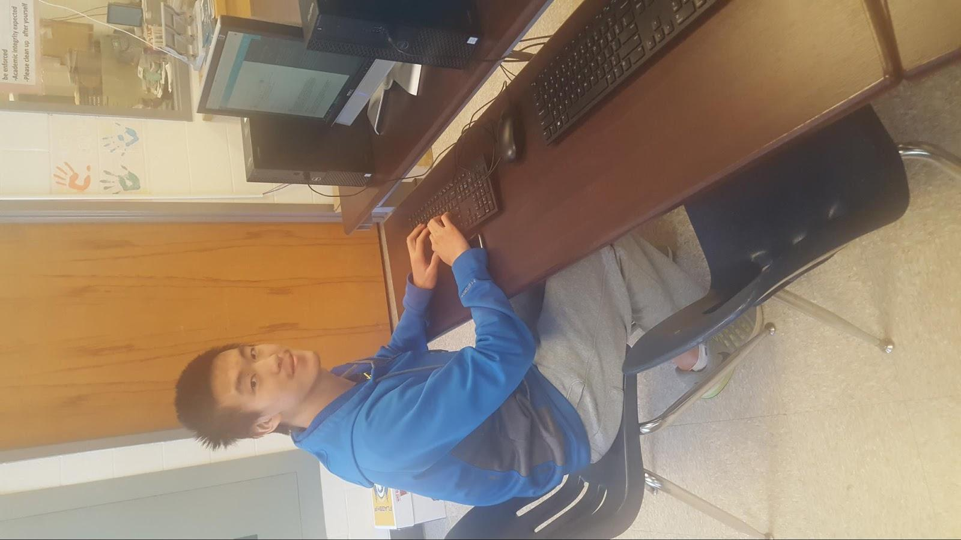

Dalton Yu

Hi! My name is Dalton Yu and I am a senior at Whitman High. I grew up in New Jersey and have spent the last seven years in Maryland. In my group, I am the project manager and housekeeper. I mainly work on writing the elements and making sure that all deadlines are met. I have taken many STEM courses, like POE, AP Physics, and AP Chem, in my time at Whitman. I have also taken English for all of my high school, so I have the solid writing skills needed for my role.

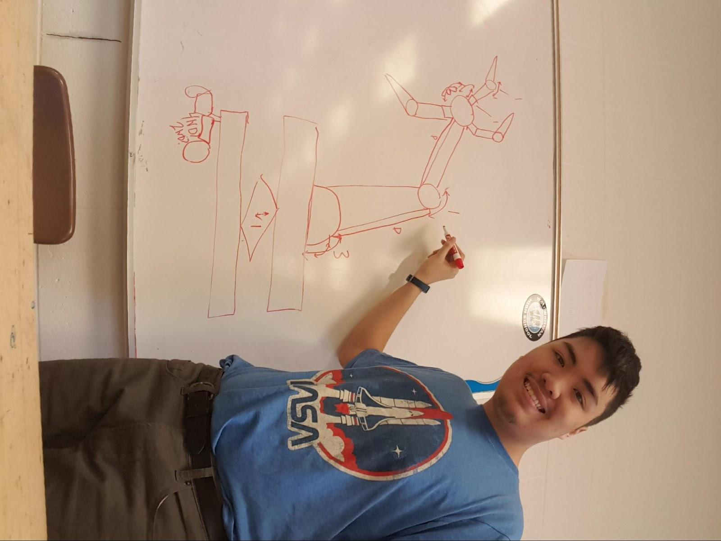

Alexander Luu​

I am also a senior at Walt Whitman High School. I grew up in Silver Spring, Maryland, and moved to Bethesda in 2012. I hold wide interests in many subjects, ranging from the traditional STEM courses to things like digital art and history. I am a jack of all trades, getting semi-involved in everyone else's work, but above all, I am an ideas person. I hope this project could be used to help people in a variety of ways.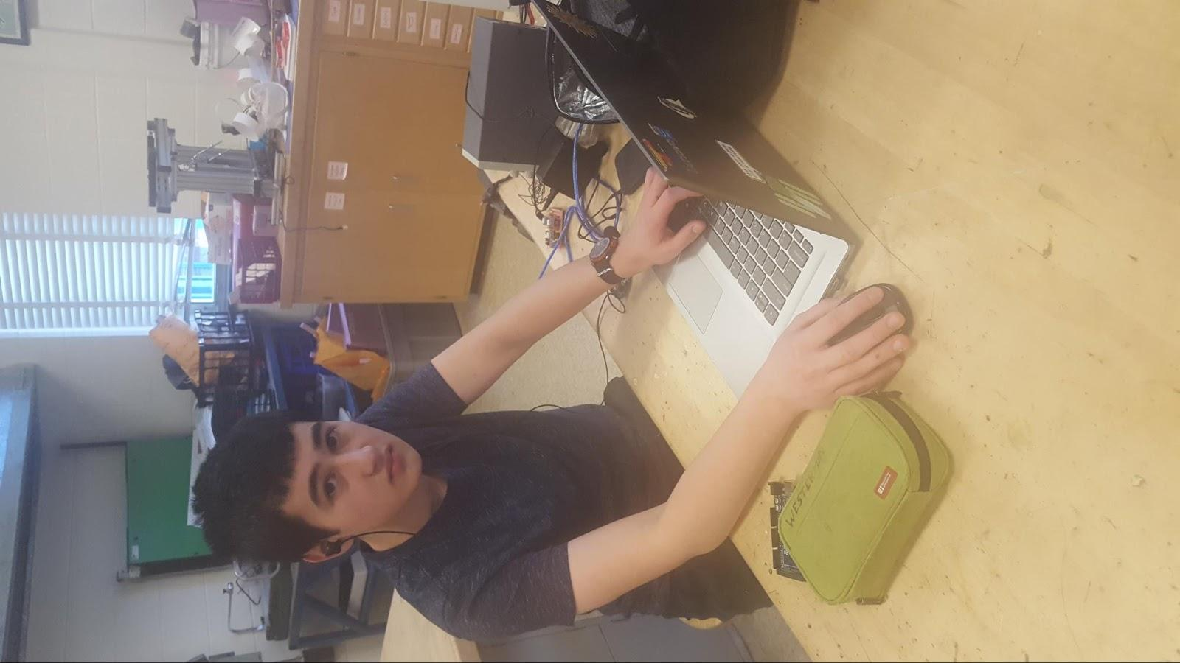

Alex Westerman​

Hi! My name is Alex Westerman. I am the software guy, in charge of writing the code for the motors and sensors for our robotic arm. I have taken many engineering and computer programming courses at Whitman. I am also an avid programmer in my free time.



Felix Xu

Ever since middle school I have been a part of many different engineering programs including IED and POE. I have also taken many science courses such as Honors Physics to supplement my engineering dream. I have always held the desire to create something which will make this world a better place and my passion for engineering will help me achieve that goal.

**Element A: Presentation and Justification of the Problem**

**Academic/ Ethical Justification**

Forklifts are a problem because they have caused many injuries and deaths for workers in companies that require the movement of heavy items. Now we have to prove that it is a problem worth spending the time and money to solve. We will research, via the Internet, articles by authorities and experts, like OSHA, Using research from the internet, articles and surveying people we will determine if there is enough evidence that forklifts are, in fact, life-threatening for workers. Extracting facts and statistics from experts will make our academic research more reliable. We will try to gather many sources so that we will have different routes to justify the problem, making the research more sound. In the ethical part of the justification, we will be looking at the morality of forklifts. From this research our design requirements can be determined.

**Academic Analysis:**

After conducting through market research we have learned that… .

1. In 2015, 3.4 out of every 100,000 workers in the U. S. die because of workplace accidents. Although this statistic is less than it was in 2006 (4.2 workers), it has not changed much from 2012 to 2015 and the rate is still pretty high, amounting to about 5000 fatalities a year. (*Fatal*) Forklift accidents contribute to this rate so we need to find a safer solution.
2. Between 2012 and 2016, the average price for an outpatient emergency room visit rose 31 percent to $1,917, according a recent Health Care Cost Institute report. (Knowles)
3. According to the Medical Cost Trend report released today from PwC's Health Research Institute, employers and insurers are expecting a 6 percent increase in healthcare costs in 2019, in line with the 5.5 percent to 5.7 percent increases seen in the past five years. (“Costs”)
4. Forklift accidents kill 85 people, 34,900 incur serious injuries, 61,800 have non-serious injuries annually. Even though this is not the most serious cause of workplace accidents, it is serious enough to warrant action. (“Forklift”)
5. In 2014, the cost to buy and maintain an internal combustion (IC) forklift over a five year period is around $85,000. For an electric forklift, the number is still huge: about $52,000. ("How")

* More than 94,000 forklift injuries occur every year, with roughly 25% of those attributed to lack of operator training. This means that the majority of forklift injuries are related to the machine itself, and not to the incompetence of the worker. Therefore, it is necessary to design an alternative to a forklift to ensure the safety of workers.
* In many places, like warehousing companies and home furniture stores, that require the movement of heavy objects, the employees utilize forklifts to make the task easier and safer. In fact, an ordinary forklift can carry up to 4,000 pounds at 24 inch standard load center (Powered). Despite this huge benefit of forklifts, they are actually more of a danger than a boon.
* There are many risks associated with operating a forklift. For instance, employees often overload a forklift or operate it with an unsecured load, which are "sure-fire ways of making [the] vehicle unstable" and potentially causing the load to fall and injure surrounding workers ("10"). Also, users often move at an unsafe speed, which can cause the forklift to crash into surrounding colleagues. Injuries that result include, bruising, broken bones, or paralyzation. Here are some specific instances. On 1/09/2017 in West Palm Beach, FL, I worker was electrocuted because a forklift ran over an electric cable. On 7/11/2018 in Magnolia, TX, a worker was fatally struck by a forklift (“Report”). The dangers are evident.
* One solution to solve this problem is to issue federal regulations and inspections and train workers how to use forklifts. There are many OSHA forklift safety regulations and training programs in place. However, it is difficult to enforce all of them because companies might forget one, and this can be dangerous. Also, even though employees go through all of this training, they could make mistakes, especially the non-experienced employees.

References

10 Forklift Fouls and How to Avoid Them. (2016, March 4). Retrieved October 12,

2018, from EHS Today website: https://www.ehstoday.com/forklift-safety/

10-forklift-fouls-and-how-avoid-them

Blanchard, D. (2015, June 8). How Safe Are Your Forklifts? Retrieved January 22,

2019, from Material Handling & Logistics website: https://www.mhlnews.com/

safe-forklifts

Costs are rising for employer-sponsored insurance - again. (n.d.). Retrieved from https://www.google.com/amp/s/www.cbsnews.com/amp/news/costs-are-rising-for-employer-sponsored-insurance-again/

*Fatal Occupational Injuries in 2015*. (n.d.). Retrieved October 5, 2018, from U.S

Bureau of Labor Statistics website: https://www.bls.gov/iif/oshwc/cfoi/

Cfch0014.pdf

Forklift Accident Statistics. (n.d.). Retrieved November 6, 2018, from

ForkliftFails.Com website: http://www.forkliftfails.com/

forklift-accident-statistics/

Forklifts: What Can Go Wrong? (n.d.). Retrieved October 23, 2018, from Atlas

Companies website: https://atlastoyota.com/blog-posts/

forklifts-what-can-go-wrong/

How much does a forklift really cost? (2014, August 6). Retrieved October 22,

2018, from Manufacturers' Monthly website: http://www.manmonthly.com.au/

news/how-much-does-a-forklift-really-cost/

Knowles, M. (n.d.). Cost of ER visits increased 31% between 2012-16: 5 findings. Retrieved from<https://www.beckershospitalreview.com/eds/cost-of-er-visits-increased-31-between-2012-16-5-findings.html>

Powered Industrial Trucks (Forklifts). (n.d.). Retrieved October 22, 2018, from

Unites States Department of Labor website: https://www.osha.gov/SLTC/etools/

pit/operations/loadcomposition.html

Report of fatalities for CY 17-18. (n.d.). Retrieved October 23, 2018, from

United States Department of Labor website: https://www.osha.gov/dep/fatcat/

dep_fatcat.html

United States Department of Labor. (n.d.). Retrieved from https://www.osha.gov/dts/osta/otm/otm_v/otm_v_2.html#7

United States Department of Labor. (n.d.). Retrieved from<https://www.osha.gov/oshstats/commonstats.html>

**Market Research Plan:**

Another important component of a well-supported justification to the problem is the market research. We have to show that there is a market for our design if successful, that people would want to invest in our product for their lives. We will make a plan on how to gather the evidence by keeping in mind some points to direct us towards a problem statement-specific plan.

Our Intended Goal and Purpose is to justify our problem statement through careful assessment of the public’s opinions and needs.

*We have identified specific objectives of forklift safety that we want to gather evidence on to fulfill our intended long term goal. These objectives include:*

* We want to find out to what extent the public believes that forklifts are unsafe for workers in industry.
* We want to learn what aspect of the forklift does the public think is the most problematic.
* We want to learn how much the public is willing to pay for an 100% safe alternative to a forklift.
* We want to learn what features/criteria our audience expects in the machine mentioned above.
* We want to find the percentage of our audience that has suffered a forklift-related injury.

*We have to keep in mind our targeted population when conducting our market research to we gather accurate evidence.* We surveyed the public using Facebook, but our targeted demographics is workers in industries, like construction, warehouse, home improvement, that require the use of a forklift to lift heavy loads.

With our basic objectives and our targeted population in mind, we want to find an effective way to gather the information we need.

We will conduct one or two surveys by asking the public questions pertaining to what they think about the safety of forklifts. We will ask them to rate the safety of a forklift from 1-10, what criteria they look for in an alternative for forklift, etc.



Market Research:

We conducted two surveys asking questions pertaining to the safety of forklifts and specific criteria the public is looking for in an alternative design. The data gathered will be used to corroborate our academic research to provide a stronger justification.

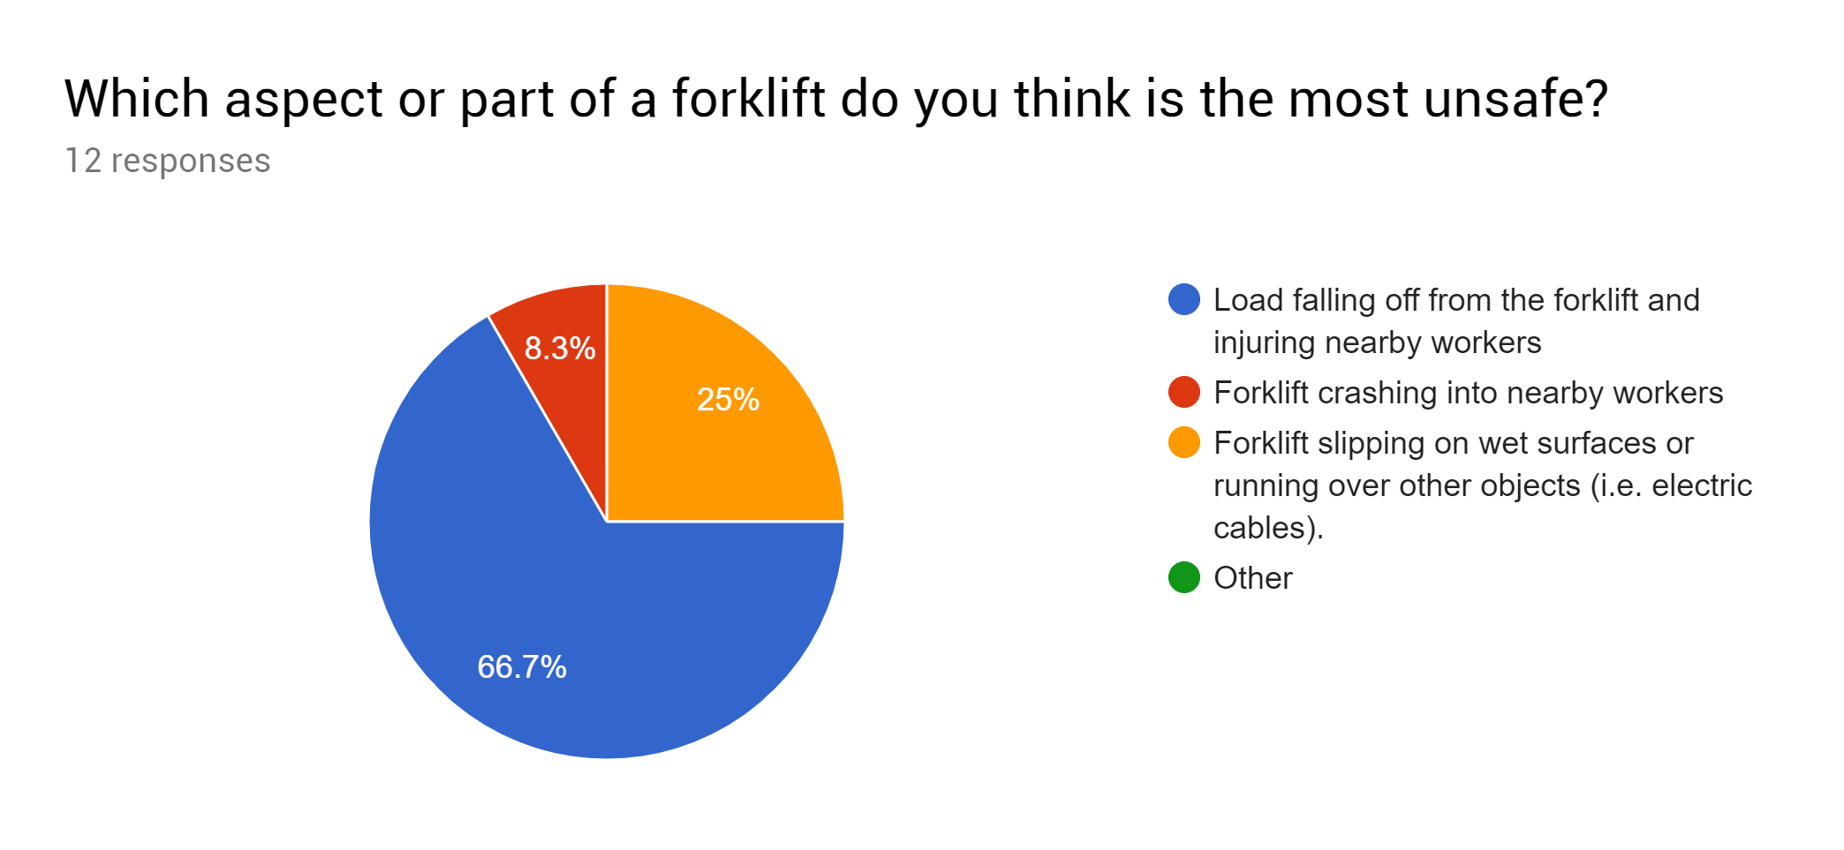

Thus we can conclude from the graph above that the most unsafe aspect of a forklift is that the load can fall off and injure nearby colleagues. This corroborates our evidence from "10 Forklift Fails and How to Avoid Them" from EHS Today that employees often overload a forklift or operate it with an unsecured load, which are "sure-fire ways of making [the] vehicle unstable" and potentially causing the load to fall and injure surrounding workers ("10").

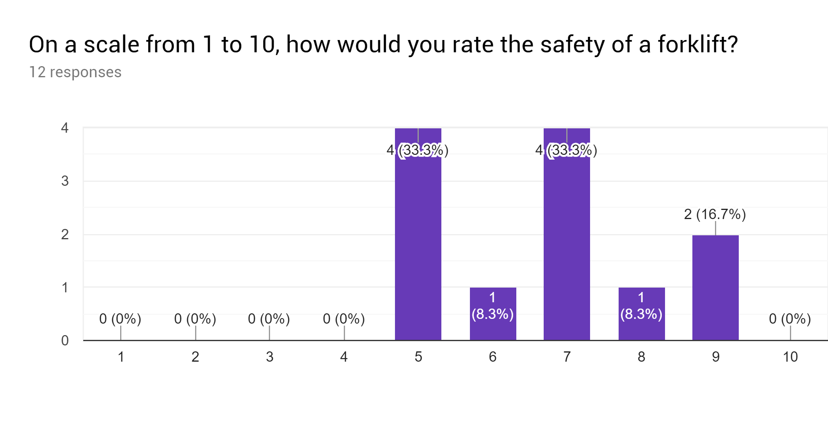

While 7/12 of our sample rated a forklift as pretty safe (7 or over), the 5/12 of it rated it a 6 or below. This shows that some people believe that there are problems with the forklift.

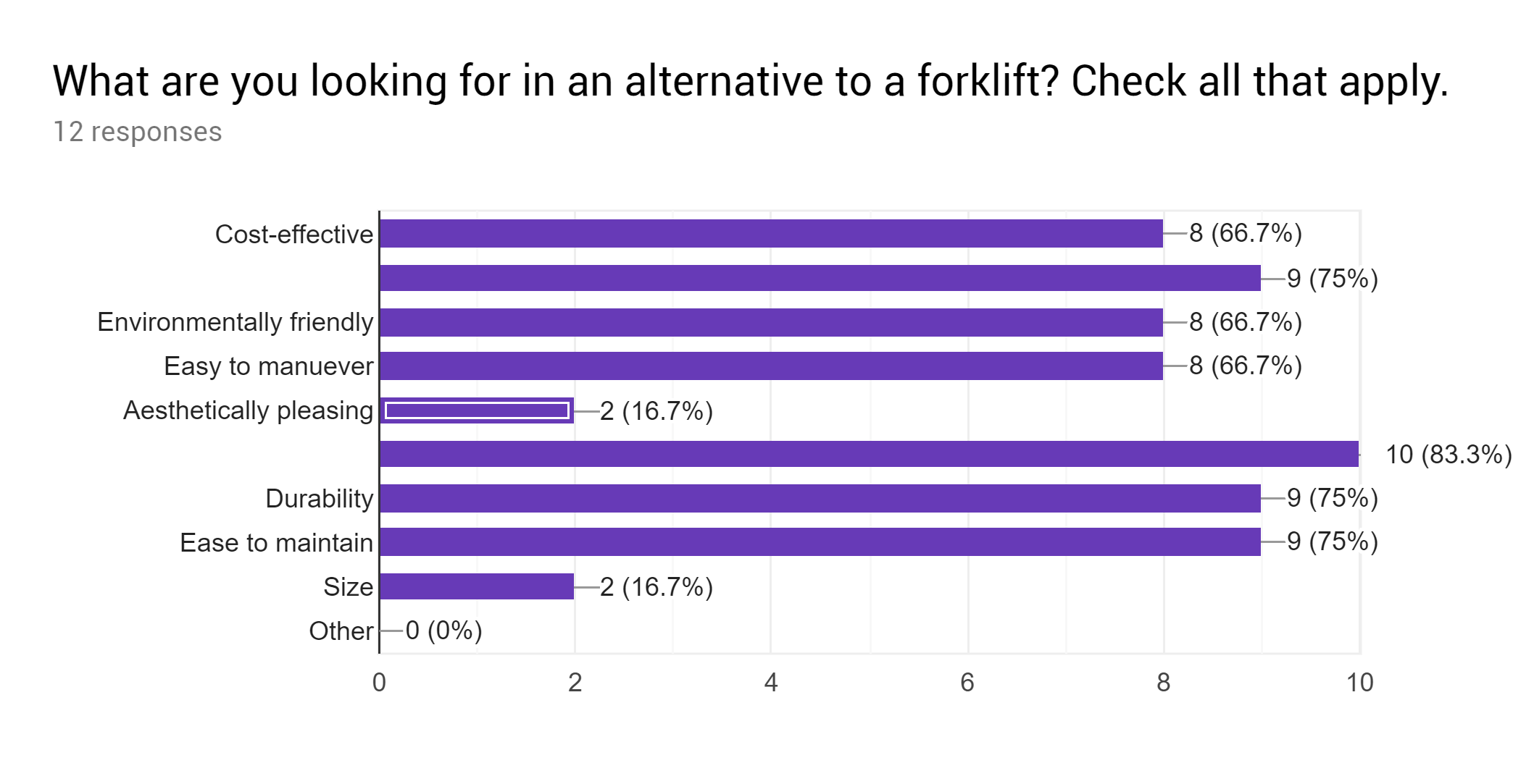

*Note: The no title rows are “safe for users and nearby colleagues” and “allows for more flexible lifting of load (unlike the forks on a regular forklift which could only move up and down)”*

From this graph, it can be seen that the majority of our sample prefers that an alternative is cost effective, safe for users and nearby colleagues, environmentally friendly, easy to maneuver, easy to maintain, durable, and flexible. Therefore, we will focus on them for Element C.

**How much are you willing to pay for an 100% safe machine that will be able to perform the same tasks as a forklift? 12 responses**

10000

2x forklift price

$15000

No clue

maybe 50% more

Not sure

$50

10,000

A lot

I don’t care about forklifts

Idk the market

500

This will be one of our design specifications: cost effectiveness. These responses show that people want a new design that costs between the cost of the forklift and 2 times of it.

<https://journals.sagepub.com/doi/full/10.5772/57525>

**Summary:**

Through our assiduous academic and market research, we found out that forklifts are dangerous to workers in construction, warehouse, home improvement industries and that it is imperative we design a safer alternative. Through statistics from reliable forklift websites and authorities like OSHA, it is evident that forklifts account for almost 100,000 injuries and deaths per year. In market research, our whole sample indicated that the most unsafe aspects of the forklift is the load falling off the forks and the forklift crashing into nearby colleagues. Also, 41.7% of our sample indicated rated the safety of a forklift, on a scale from 1-10, a 6 or below. Through market research it is evident that forklifts are unsafe, and therefore a serious problem.

**Element B: Documentation and Analysis of the Prior Solution**

**Prior Solution Analysis**

We analyzed prior attempts to solve this problem to show how they weren't sufficient, which shows that there is still a problem, justifying a new design. This process allows us to balance past attempts of solving the problem with current problems. This will also help us generate ideas for our design. We will accomplish this by researching previous products and assessing their pros and cons.

|  |  |  |  |  |
| --- | --- | --- | --- | --- |
| **Prior Attempt/Related Problem** | **What it is….** | **Source** | **Strengths** | **Shortcomings** |
| Smart Auxiliary Assistive Robotic Arm (SAARA) | A mid specs arm that attaches to a table or chair. It contains joints that assist in  moving light and small objects | Smart Auxiliary Assistive Robotic Arm (SAARA). (n.d.). Retrieved  from KickStarter database. | * Adaptive gripper could grip a variety of shapes * Workers don’t have to stand to get objects * Easy to carry and store. | * Could only carry a max load of 500 grams * Needs ample trials and testing to put it on market * Not that durable: the arm is thin |
| xArm | A carbon-fiber multi-purpose robot arm that could perform a variety of industrial tasks, like lifting, loading, filming, and service automation. You would just use different end-actuators which each perform a unique function. | xArm – Most Cost-Effective Intuitive Industrial Robotic Arm. (n.d.). Retrieved  from KickStarter database. | * Cost-effective: 50% lighter than regular industrial robot * Carbon-fiber allows flexibility while ensuring robustness * Quick setup: 10 minutes * Visually appealing * Omnidirectional | * The max load it could carry is 5 kg, which would not suffice in industries that require the movement of heavy loads * Only 691mm long so it could only perform close range tasks. * Not able to move long distances |
| Regal (™) Manual Stackers | A forklift-like lifting machine that allows to carry load load stacked on top of each other. | Manual Stackers Are Economical Alternative To Forklift. (2006, April 27).  Retrieved October 24, 2018, from Thomasnet website:  https://news.thomasnet.com/companystory/  manual-stackers-are-economical-alternative-to-forklifts-483474 | * Maximum load is 1000 lbs which is the amount for heavy objects like furniture. * The load is attached and not free like in the forklift,so this solution is much safer * Sturdy glass wall to separate the operator and the load | * It still requires lengthy regulations and worker training. * The forks are only able to move up and down, not left or right * High risk of load falling off |
| Dexter | Robotic arm aimed for personal uses in a community | Dexter. (n.d.). Retrieved from KickStarter database. | * Size allows for it to fit in small spaces * Rotation points can offer lots of possibilities * Easy to maintain and operate | * Non-human controls require knowledge and skills in programming to use * Circuits and wiring systems exposed, make the structure and functionality more vulnerable. * Not enough durable. |

**Current Patents**

In addition to analyzing previous solutions, we also have to research patents to bolster our justification on why prior attempts were not successful to provide us with legal justification.

|  |  |  |  |  |
| --- | --- | --- | --- | --- |
| Patent | Description | Strengths | Shortcomings | Source |
| Handicapped-resisting mechanical arm (CN201049462Y) | This devices helps elderly and disabled people perform daily functions easily. This mechanical arm uses a main double rocker mechanism to allow for movement without a power supply. | * User-manipulated, with pedal that user presses with feet to control the actions of the mechanical arm. * No need for power supply * Mobile | * Can’t grab heavy loads * Only is useful for disabled or elderly people. * Double rocker mechanism can make the load more vulnerable. | Zhu, X. B., Zhu, L. Y., & Ge, Y. H. (2006-12-12). *China Patent No. CN201049462Y*. Beijing: China Patent and Trademark Office. |
| Industrial robot for safe handling of heavy load (DE102011084007A1) | Industrial robot for safe handling of heavy load, has robot arm moved relative to lifting mechanism in horizontal plane by joints, and resilient clutch arranged in joint so as to ensure actuator decoupled motion of robot arm segment | * Lifting mechanism which allows the arm to move up and down along the vertical support * Resilient clutch arranged in joint to allow for flexible movement. * Flexible lifting mechanism | * Not mobile so workers have to carry it everywhere * Arm is made of wood which is very not strong * Will not lift very heavy loads. | Ferrara, P., Loizmayr, S. Naderer, R. (2010-10-05). *Austria Patent No.*DE102011084007A1. Vienna: Austrian Patent Office. |
| Robotic arm system which uses camera sensing programs to detect movement of the person wearing the harness device (US9056396B1) | Robotic arm system which uses camera sensing programs to detect movement of the person wearing the harness device, which has controls for the uses, and translate that program into the robotic arm. Program creates a replication of motion paths by a person's arm and has the arm follow the same path. | * Human controlled * Utilizes demonstration tool and the robotic arm replicates the movements * Uses a camera for accurate replication | * Not so convenient-involves a lot of setup * It might be hard for the robot to exactly replicate the movements of the human. * Only good for motion * Costly | Linnell, J. (2013-03-05). *U.S. Patent No.* (US9056396B1) . Washington, DC: U.S. Patent and Trademark Office.  <https://journals.sagepub.com/doi/full/10.5772/57525> (Scientific journal on this) |

**Summary of Element B**

Through our research of existing solution attempts and patents, we discovered that they are not sufficient for a number of reasons. A lot of existing solutions, such as robotic arms, were designed for everyday use and not to lift heavy loads. For example the SAARA and the XArm are clearly not useful for carrying heavy loads because the max load they can carry is 0.5 and 5 kg respectively. Also many of the existing solutions are costly and tedious to implement and maintain like patent US9056396B1. They also need a lot of regulations. Moreover, many of the existing solutions above operate with a not fully secured load, which, as we stated in element A, is dangerous for nearby workers. Thus, because existing solutions do not solve, and even exacerbates, our problem, we have to find another solution.

**Element C: Presentation and Justification of Solution Design Requirements**

**Specifications Priority List**

**Through our survey and our academic research, we have identified a set of requirements that our design must have to solve our problem and achieve our intended outcome.**

1. **Must be safe to the user and surrounding people.**
2. **Must be able to carry a load of around 3000-5000 pounds and secure it**
3. **Must have a flexible arm to carry the load**
4. **Must have a service life of at least five years/must be durable**
5. **Must be adaptable and versatile**
6. **Must be easy to use**
7. **Must cost from 10000 to 50000 dollars**
8. **Must be environmentally friendly**
9. **Must exceed operating speed and stopping distance requirements of a forklift**

**Justification of Specifications Using Academic and Market Research**

* **Must be safe to the user and surrounding people**

This is our number one priority and goal: we want to design a safer alternative to a forklift, which, according to our academic research on forklift deaths and issues, is obviously dangerous. Also, according to our survey, 100% of our respondents said that they prioritize safety in an alternative to a forklift. This directly bolsters our problem statement. (Market Research)

* **Must be able to carry a load of around 3000-5000 pounds and secure it.**

According to CostOwl.com, standard warehouse forklifts (our targeted population) can lift loads of 3000-5000 lbs to heights of up to 20 ft (“How”). We have to design an alternative that performs the same task. Also, the website EHS Today states that an unsecured load is a major problem with forklifts. For instance, employees often overload a forklift or operate it with an unsecured load, which are "sure-fire ways of making [the] vehicle unstable" and potentially causing the load to fall and injure surrounding workers ("10"). (Academic/Ethical Research).

10 Forklift Fouls and How to Avoid Them. (2016, March 4). Retrieved October 12,

2018, from EHS Today website: https://www.ehstoday.com/forklift-safety/

10-forklift-fouls-and-how-avoid-them

How Much Does a Forklift Cost? (n.d.). Retrieved January 22, 2019, from

CostOwl.com website: http://www.costowl.com/b2b/forklift-cost.html

* **Must have a flexible arm to carry the load**

According to our survey, 100% of the survey responses indicated that they want an alternative that can lift objects in a more flexible method. Forklifts are too rigid and are limited by their forks moving up and down. (Market Research)

* **Must have a service life of at least five years/must be durable**

According to adaptaliftGroup, The average service life of an internal combustion forklift is about five years, so this design must have the same service life or longer. (Academic/Ethical Research)

The Optimal Time to Replace your Forklift. (2012, October 24). Retrieved January

22, 2019, from adaptaliftGroup website:

https://www.aalhysterforklifts.com.au/index.php/about/blog-post/

the_optimal_time_to_replace_your_forklift

Sullivan, J. (2016, December 13). How Long Will An Average Forklift Last?

Retrieved November 6, 2018, from Toyota Material Handling: Northern

California website: https://www.tmhnc.com/blog/

how-long-will-a-forklift-last-and-forklift-average-use

* **Must be adaptable and versatile**

Besides warehouse, produce, and home improvement companies, construction sites use forklifts. There is a special class of forklifts called “Rough Terrain Forklifts” that can drive on rough surfaces. Therefore, our design must be able to operate in a variety of indoor and outdoor environments. (Academic/Ethical Research)

Types of Forklifts: Selecting the Right Equipment for the Job. (n.d.). Retrieved

January 23, 2019, from Nitco website: https://www.nitco-lift.com/blog/

types-of-forklifts/

* **Must be easy to use**

According to our market research, 100% of our respondents indicated that their top specification in an alternative design is that it is easy to maneuver. Therefore we need to make our prototype user friendly. There must be little to no regulations and worker training in order to operate the product, which is one the components of our problem statement. (Market Research)

* **Must cost from 10000 to 50000 dollars**

The responses for the question, “How much are you willing to pay for an 100% safe machine that will be able to perform the same tasks as a forklift?” were, “10000” and “2x forklift price.” According to CostOwl.com, a brand-new standard capacity forklift costs anywhere from $15000 to $25000. Therefore, our desired cost range is 10000 to 50000 dollars for our design. (Academic/Ethical Research)

How Much Does a Forklift Cost? (n.d.). Retrieved January 22, 2019, from

CostOwl.com website: http://www.costowl.com/b2b/forklift-cost.html

* **Must be environmentally friendly**

50% of our survey respondents said that they prefer a design that is environmentally friendly. Therefore, we need to design a machine that minimizes usage of electricity and fossil fuels as much as possible. We will aim to use renewable sources of energy. (Market Research)

* **Must exceed operating speed and stopping distance requirements of a forklift**

National Safety Inc. states that if a forklift is traveling 4 mph, the stopping distance is 17 ft. If the speed is 8 mph, then the stopping distance needed is 47 ft. This is the criteria our new design must meet. Preferably we should reduce the stopping distances to ensure that it is more safe for surrounding workers. (Academic Research)

**The Basics of Forklift Safety (Part 3). (2010, February 9). Retrieved January**

**23, 2019, from National Safety, Inc. website: https://nationalsafetyinc.org/**

**2010/02/09/the-basics-of-forklift-safety-part-3/**

**Constraints**

Constraints, or external limiting factors, to an engineering project are important to keep in mind so we can plan accordingly.

* This project has to be completed by May 1, 2019 for review by jury.
* We have an $100 budget.
* Construction time is 2 weeks

**Summary of Element C**

**There are many criteria and constraints that need to be considered. Safety, cost, and time are important ones. There are also small, but vital, ones, like environmental impact, flexibility, and service life. By justifying our design specifications and constraints using our academic and market research, we are able to show that our specifications are not just random guesses, but that they have merit because they are well substantiated. These design criteria will be important in element D when we have to brainstorm possible ideas and justify them using the criteria. Also, we will adhere to these specifications throughout the building phases.**

**Element D:** DESIGN CONCEPT GENERATION, ANALYSIS, AND SELECTION

Now that we have identified the criteria our design must follow, in this element, we will brainstorm ideas that follow our design criteria. Then we will narrow the ideas down to one and make a concept sketch. By adhering to the specifications, our final design solution will be well-justified.

**Specifications Priority List**

* **Must be safe to the user and surrounding people.**
* **Must be able to carry a load of around 3000-5000 pounds and secure it**
* **Must have a flexible arm to carry the load**
* **Must have a service life of at least five years/must be durable**
* **Must be adaptable and versatile**
* **Must be easy to use**
* **Must cost from 10000 to 50000 dollars**
* **Must be environmentally friendly**
* **Must exceed operating speed and stopping distance requirements of a forklift**

**Brainstorming**

This brainstorming / documentation step is important because everyone has different ideas and we have to consider all of them to make a sound decision. Each group member sketches a possible solution in their engineering notebook and justifies it using the design specifications.

|  |  |  |  |  |
| --- | --- | --- | --- | --- |
| **Title of Work**  **Picture of Brainstorming from Engineering Notebook (here)** | **Designer** | **Description** | **Operation** | **Justification: This design meets the following specification: (must meet at least 3-6 criteria)** |
| Robotic Arm on an Omnidirectional Platform | Alex Westerman | A robotic arm with a 3-pronged gripping mechanism, mounted on a platform that has omnidirectional movement. The arm is jointed at three points, one connecting to the | Uses some form of joystick control, or motion tracking using Intel Realsense SDK | This design allows for omnidirectional movement and lifting, compared to a real forklift which has certain limits to its movement. The device is easy to control given the nature of the machine’s movement. The device can also be resized for the specific purpose that it is needed |
|  | Alex Westerman | A forklift retrofitted with a suspension system similar to that of a Mars Rover. The actual lifting mechanism supports electromagnetic attraction, and packages can be fitted with magnets to ensure grip. Proximity sensors are positioned across the machine | Remote control by joystick or host machine. Autonomous mode possible, but may decrease safety of work environment | This design allows the machine to lift objects on rough terrain, which can be especially useful for outdoor work areas. The device allows for auto stopping given the proximity sensors, and packages can be placed on the lifting mechanism without any human intervention, increasing the safety of the machine itself. |
| Le Epic Vending Machine | Alex Westerman | A vending-machine-like design with an alternative retrieval method. Desired item is extracted using an arm that will grab at a mount point, then will drag item out of shelving, then rotate orthogonally and lower so end recipient can grab item. | A controlled motor with preset motor values will be given commands by a computer/host machine, to access a specific actions, then executes accordingly | Very easy to use and reprogram. The system is also extensible and can be shifted and altered as needed. This solution can also increase safety by removing the need for an active human being to be in the vicinity of the operation |
|  | Dalton Yu | A lifting vehicle that uses a tightly secured platform to lift the load to its desired height. | Upon user command, this vehicle moves up to the load and commands the platform to slide under the load. Then the platform with the load slides onto the hooks, and they will lift it up to a certain height. Then the platform will move out of the hooks and back to where it picked up the load. | * User controlled * Electrically powered * Not expensive * Safe for the operator |
|  | Dalton Yu | This solution is essentially a cart with a robotic arm extension that grabs the load. | The user operates it using a remote control that indicates different movements and actions (eg. move forward, turn left, lower arm, grab load). The arm is able to move flexibly because of the joints. | * User controlled * Carbon fiber arm for durability * Max speed of 5mph * Flexible |
|  | Dalton Yu | This solution mimics a vending machine and drops off boxes for pick up. Also it has many conveyor ramps that carry items from place to place; | The user presses a button on the glass box which which sends an electrical signal to the platform corresponding to each letter/number. The platform drops the box to the conveyor belt. The user then indicates whether to pick up the box or for the box to continue on the belt. Then he can indicate which letter/number the box goes to. The corresponding conveyor ramp carries the box there. | * User controlled * Safe for employees * Electrically powered |
|  | Alex Luu | A larger-than-life humanoid robot, with all the functions that a normal human will have. | The robot will be controlled by a human in another room, using virtual reality and motion tracking technologies to mimic the user’s movements in the robot. | * Adaptable to any environment without severe modification * Controlled by user remotely * Can rotate easily |
|  | Alex Luu | A series of drones will pick up selected packages and move them to designated locations. | The drones will either be pre-programmed before doing a job, or remote-controlled in real time like any drone. | * Autonomous or user controlled * Extremely mobile * Very cheap (most practical) |
|  | Alex Luu | Integrating a forklift with a scissor lift, the device will effectively work as a forklift, except it looks like a scissor lift. | Remote controls will allow a user to operate the fork scissor lift like either a scissor lift or a forklift from afar. If necessary, it can be manually operated. | * User-controlled * Compact, but expandable |
|  | Felix Xu | Use of 3D motion tracking software to translate real human arm movements and replicate them into a robotic arm. On a mobile platform to get it around places | Operator wears a outfit (like a shirt) which contains motion sensors. The sensors send signals to a transceiver which in turn, sends motion data to the respectable arm and movement in the robotic arm starts. | * Durable body and arms provide long service life * Hybrid tires give allows for operations in multiple environments * Omnidirectional motors provide flexibility * Easy to operate |
|  | Felix Xu | A small robot with a robotic arm which is attached to the rail system on the shelfs. The arm will grab the package and bring it down to the ground | Operator’s office is located near the shelf with a series of controls (joysticks) which will move the robot along the self as well as the arm | * Joint motors offer flexibility * Not very large, reducing accident rates * Fulfills role of a forklift * Easy to operate * Long service life * Omnidirectional joint motors provide flexibility |
|  | Felix Xu | Vehicle portion is similar to a forklift. The prongs are replaced by a single arm, 3D sensor controlled, with a large electromagnet on the end to grab objects | Operators cabin housed at the back to distribute weight of the vehicle. Use of same motion tracking system to allow for simple and easy movement of the arm. | * Operates in the same space as a forklift * Arm fulfils functions or a forklift |

**Peer Review**

**In this step of element D, our peers from other groups critiqued my group's ideas using post-it-notes. Our peers' comments helped us rule out any ideas that are not viable given our time and money constraints. Unfortunately, their notes mainly taught us that this problem wasn’t worth solving. This activity helped us for our decision matrix.**

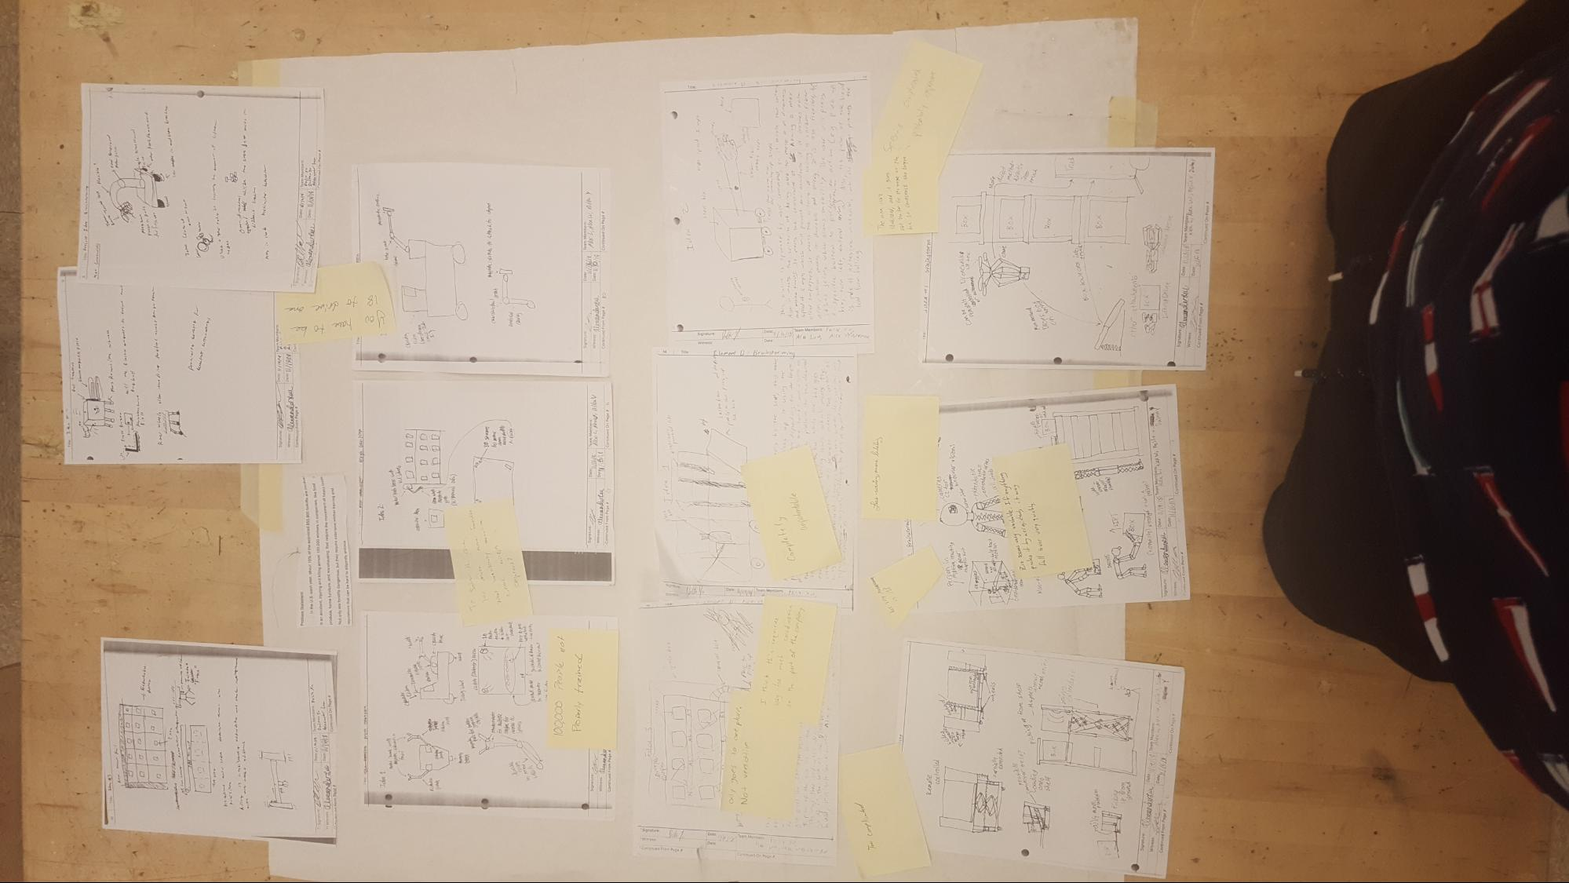

**Decision Matrix**

**The decision matrix is an important engineering principle. We are using this tool to narrow down our ideas to one idea based on our criteria and constraints. We assign each criteria a score from 1 to 10 and add them all up.**

|  |  |  |  |  |  |  |  |  |  |  |  |
| --- | --- | --- | --- | --- | --- | --- | --- | --- | --- | --- | --- |
| **Idea and Designer** | **Size** | **Cost** |  | **Durability** | **Flexibility** | **Safety** | **Service Life** | **Ease of Use** | **Ease to Maintain** | **Energy Use** | **Total** |
| 1. Robotic Arm on an Omnidirectional Platform (Alex W.) | 8 | 6 |  | 5 | **10** | 6 | 4 | 7 | 5 | 5 | 56 |
| 2. Electromagnetic Forklift with Suspension (Alex W) | 8 | 2 |  | **10** | **10** | 7 | 9 | 8 | 5 | 4 | 63 |
| 3. Vending Machine-Like with Retrieval Arm (Alex W) | 1 | 3 |  | 9 | 5 | **10** | 9 | 8 | 6 | 4 | 55 |
| 4. Electrical Double Protected Lifting Vehicle (Dalton) | 2 | 3 |  | **10** | 4 | **10** | 8 | 5 | 5 | 7 | 54 |
| 5. Extendable Simple Robotic Arm (Dalton) | 8 | 6 |  | 2 | 9 | 1 | 4 | 7 | 8 | 7 | 52 |
| 6. Vending Machine-Like Conveyor Belt Device (Dalton) | 1 | 2 |  | **10** | 2 | **10** | **10** | 4 | 3 | 6 | 48 |
| 7. Pinball Claws (f. Many Drones) (Alex L) | **10** | **9** |  | 4 | **10** | 5 | 9 | 9 | 8 | 5 | 69 |
| 8. Humanoid Robot (Alex L) | 4 | 4 |  | 7 | 8 | 7 | 6 | 7 | 4 | 4 | 51 |
| 9. Fork Scissor Lift (Alex L) | 6 | 7 |  | 4 | 4 | 5 | 8 | 5 | 4 | 3 | 46 |
| 10. Omnidirectional Robotic Arm on a Moveable Platform (Felix) | 8 | 7 |  | 8 | **10** | 8 | **9** | **10** | 7 | 6 | **73** |
| 11. Package Vending Machine (Felix) | 1 | 3 |  | 7 | 6 | 9 | 7 | 7 | 7 | **8** | 55 |
| 12. Magnetic Arm on Moveable Platform (Felix) | 7 | 6 |  | 9 | **10** | 9 | 7 | 7 | **9** | 6 | 70 |
|  |  |  |  |  |  |  |  |  |  |  |  |
| **Hyper-Redundant Bending Machine [Maximum score]** | **10** | **10** |  | **10** | **10** | **10** | **10** | **10** | **10** | **10** | **90** |

|  |
| --- |
| Green = Excellent |
| Yellow = good |
| Orange = meh |
| Red = bad |
| Brown = terrible |

|  |
| --- |
| **Grading Scale** |
| 1 = least optimal |
| 10 = most optimal |

**Reflection on the Decision Matrix**

The decision matrix helped us organize our brainstorming ideas and narrow them using our specifications and constraints. Without the matrix, we wouldn’t have a standard to which to choose our final idea; it would be a mess. Each idea has its benefits and drawbacks; the matrix allows us to isolate each one and then add the scores up for a final score. One disadvantage the decision matrix is that personal opinion might affect the scores you assign to each criteria.

Ultimately, we decided that none of these ideas could fully fulfil the requirements necessary for our purposes, so we ended up combining elements from almost all of the ideas to create the final design. The final design will take elements primarily from Felix’s #10 and Alex W’s #1, with elements from Alex Luu’s #9 and Dalton’s #5.

**Concept Sketch**

**A concept sketch is a detailed and annotated sketch of our final design. This sketch will be important later when we have to make our materials list and design our prototype. Having the design planned out makes it easier later. We describe how this design operates and how it meets the criteria.**

|  |  |  |
| --- | --- | --- |
| Concept Test Mock UP 3D Drawing | How does it operate? | Justification of how it meets specific Criteria |
|  | Operator wears a outfit (like a shirt) which contains motion sensors. The sensors send signals to a transceiver which in turn, sends motion data to the respectable arm and movement in the robotic arm starts. The length will be about 6ft, the width 4ft and the height from the bottom to the top of the motion receiver 4.5 ft. At full extension of the scissor lift the height will be about 7 ft. The arm’s full length will be about 10 ft. | * Durable body and arms provide long service life * Hybrid tires give allows for operations in multiple environments * Omnidirectional motors provide flexibility * Easy to operate * Arm made out of Balsa wood which ensures durability. * Easy to control: arm just mimics your motion. * Materials in the design are not so expensive - just motors and sensors |

Summary of Element D:

We brainstormed possible design concepts and justified them using our design specifications, went through a peer review of our ideas, made a decision matrix to narrow our ideas down, and finally made a concept sketch of our final design. This element was valuable because by going through a detailed process of generating and evaluating multiple design ideas, we were able to rule out ideas that are not viable and justifiable and come to a conclusion on a design solution.

**Element E: STEM Principles**

**A stem principle is a concept or principle that we have learned in our math, science, and engineering courses in our high school that can be used to justify and build our design. These are important because we want to prove that our ideas were not just guesses and were based on sound scientific knowledge. By justifying our design using STEM principles, we will show that it has merit.**

**In the chart below, we have identified many STEM principles and concepts and the purposes that each concept will serve that will go into designing our prototype. We have also included various resources and the testimonies of experts who will review and verify our applications of the STEM principles in order to make them more sound.**

|  |  |  |  |  |  |  |  |  |
| --- | --- | --- | --- | --- | --- | --- | --- | --- |
|  | **Factor or Action Taken** | **Principle to Consider** | **STEM FIELD**  **(Math, Engineering, Science, Computer Science)** | **Relationship to the design** | **Forces to Consider** | **Describe who can help you validate your STEM work. What training or credentials will your experts need to have?** | **Discussion with Expert** | **Resource (APA Format)** |
| **1** | **Materials Testing** | **Stress/Strain** | **Engineering** | **We need to test our arm design to see how much load it can hold without permanent deformation.** | * **Stress vs. Strain curve** * **Cross sectional area of arm** * **Calculate breaking force. Force = Breaking Stress * CS Area** * **Strain = Change in length / original length** | **None, we will test stress/strain on our own using scale and ruler.** | **N/A** | **Peshin, A. (n.d.). What Is The Stress-Strain Curve? Retrieved January 10, 2019,**  **from Science ABC website: https://www.scienceabc.com/innovation/**  **what-is-the-stress-strain-curve.html** |
| **2** | **Building the wrist and arm** | **Programming motors, Stress/Strain, Torque** | **Computer Science/POE** | **The wrist and arm need joints that are mobile and flexible. We will attach motors on the joint. The wrist needs to be able to rotate and move in all directions, one of our criteria.** | * **How to convert electrical energy into kinetic energy.** * **Formula for torque: ꞇ = Fsinθ*r, where force is F and radius is r.** * **Connects with Stem Principle 3** | **Contact with a robotics design expert on how to attach motors to the wrist.** | **Discussion with Gary Davis on 4/4/19. See correspondence log in Element G.** | **N/A** |
| **3** | **Robot Control System** | **Robotic Systems, MCU (Main Computer Unit) Development** | **Computer Science/ Digital Electronics** | **A control system or interface must be developed to send proper signals and electric power to the motors in a effective way** | **Knowledge of hardware and software.** | **Gary T. davis or another NASA expert on robotics.** | **We discussed with him on 4/4/19 in class. See Element G.** | **N/A** |
| **4** |  |  |  |  |  |  |  |  |
| **5** | **Calculate stopping distance** | **Force/kinematics** | **Physics** | **One of our criteria is that our design must have a maximum stopping distance of 17 ft for speed of 4 mph.** | * **How to combine two equations (one for kinematics and one for F = ma)** * **f=ma, 𝞵mg = ma, a = 𝞵g (f is force of kinetic friction)** * **vf^2 = vo^2 + 2a𝚫x** | **N/A** | **N/A** | **Stopping Distance Formula. (n.d.). Retrieved January 10, 2019, from**  **SoftSchools.com website: http://www.softschools.com/formulas/physics/ stopping_distance_formula/89/** |
| **6** |  |  |  |  |  |  |  |  |
| **7** |  |  |  |  |  |  |  |  |
| **8** |  |  |  |  |  |  |  |  |
| **9** | **Calculate energy output** | **Work and Power, Current/Voltage** | **Physics** | **We will calculate the energy output of the robotic arm over a period of time to see if it meets our constraint of being environmentally friendly.** | * **Vernier Pro, take area under Power vs time graph.** * **Also, Ohm’s law, V= IR. Power = IV.** | **No need, we know how to use a Vernier.** | **N/A** | **Ohm's Law. (n.d.). Retrieved January 11, 2019, from The Physics Classroom**  **website: https://www.physicsclassroom.com/class/circuits/Lesson-3/Ohm-s-Law** |

**Discussion with experts: We need to meet with experts in order for them to verify that our application of our STEM Principles is correct.**

* **A NASA scientist at Goddard Space Flight Center: We haven’t emailed him yet because we are still planning what questions to ask him.**
* **McMaster Carr expert on pneumatic cylinders and pistons**

**Question to post on Whitnet:**

**Hi All,**

**My name is Dalton Yu and I am a senior at Whitman. I take the Project Lead the Way capstone course, Engineering Design and Development. My group is designing a prototype for a computer programmed robotic arm that will assist employees in the movement of heavy loads. Are there any parents who are or know any robotic design experts that could help us with the structural design aspect of our project? If yes, could you please provide their contact information?**

**Thank you for your time,**

**Dalton Yu**

**Engineering Principles**

These are concepts that we have used in design projects in our previous engineering courses, like planning and documentation. We want to show that our procedure is based on sound logic and methodology to further prove the merit of our design.

Gantt Chart: This is important because all engineers need a project plan in order to be able to meet the deadline. Alex L, Felix, and I started research in the beginning of October, and Alex W started around the same time on the computer code because that takes a long time to make.

Documentation (Engineering Notebook): A big part of a design project is the process. Every engineer needs to document his or her everyday tasks, take pictures, and post major points of project to show the process that led to the final outcome. 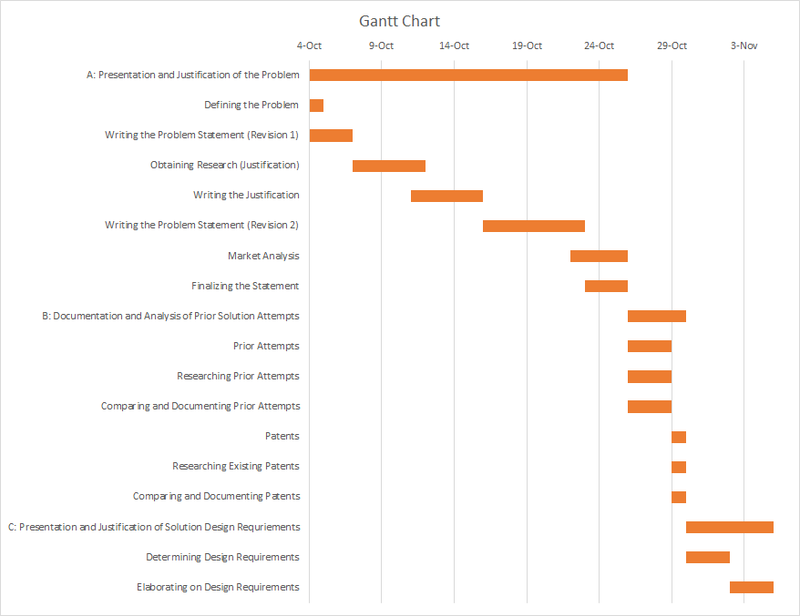

**Summary of Element E:** In this element, we clearly defined STEM and engineering principles and explained their importance to our design. We need a lot of physics and computer science concepts to test our design. In addition we put our Gantt chart under Engineering Principles.

**Element F: Design Viability**

We have justified our proposed design using STEM principles to show that our design has scientific merit. In this element we are considering whether it has a real-world value. We are asking ourselves whether our design solution is viable, or it has the capability to address our problem and people will invest their money to buy it. This element ties back to our academic and market research.

The concept sketch and the justification of our design is shown below. We’ll be assessing the viability of this design by looking at different factors.

|  |  |  |
| --- | --- | --- |
| Concept Test Mock UP 3D Drawing | How does it operate? | Justification of how it meets specific Criteria |
|  | Operator wears a outfit (like a shirt) which contains motion sensors. The sensors send signals to a transceiver which in turn, sends motion data to the respectable arm and movement in the robotic arm starts. The length will be about 6ft, the width 4ft and the height from the bottom to the top of the motion receiver 4.5 ft. At full extension of the scissor lift the height will be about 7 ft. The arm’s full length will be about 10 ft. | * Durable body and arms provide long service life * Hybrid tires give allows for operations in multiple environments * Omnidirectional motors provide flexibility * Easy to operate * Arm made out of Balsa wood which ensures durability. * Easy to control: arm just mimics your motion. * Materials in the design are not so expensive - just motors and sensors |

**We have to consider whether our design has real-world merit. In other words, can it be implemented for the public to use?**

Our proposed design has merit beyond the classroom as a real solution because there have been successful patents for similar designs. For example, patent US9056396B1, with a priority date of 3/5/13, is a tool that allows for a robot to replicate the motions of a demonstration tool, which shows that motion capture systems have been already patented. Today, there are many robots used for industrial purposes. In fact, 90% of robots in use are in the industrial robotics sector in factories. This statistic shows that building a robotic arm alternative to a forklift holds merit.

Linnell, J. (2013-03-05). *U.S. Patent No.* (US9056396B1) . Washington, DC: U.S. Patent and Trademark Office.

Bengtson, H. (n.d.). Advantages of Robotics with Emphasis on Industrial Robotics

Technology. Retrieved January 18, 2019, from Bright Hub Engineering

website: https://www.brighthubengineering.com/robotics/

76606-advantages-of-robotics-in-engineering/

**Sustainability and Environmental Impact: A design needs to be environmentally friendly and use the least possible energy to be viable.**

Manufacturing our design will not use up a lot of energy or fossil fuels so it will be sustainable. Even though cutting wood in the shape of arm uses electrical energy, the arm’s use of a hydraulic and pneumatic systems will compensate for that because water and air are inexhaustible energy sources. Also, making this design doesn’t require the burning of fossil fuels as it will be supplied using electricity, which are in low supply now.

**We have to prove that our targeted population will invest their money in this idea in order for it to be marketable.**

Forklift accidents kill 85 people, 34,900 incur serious injuries, 61,800 have non-serious injuries annually. In fact about 10% of the over 800,000 estimated forklifts cause an injury and death every year. Thus, it is imperative for a company to invest their savings in this idea in order to prevent its employees from suffering injury or death.

Forklift Accident Statistics. (n.d.). Retrieved November 6, 2018, from

ForkliftFails.Com website: http://www.forkliftfails.com/

forklift-accident-statistics/

**Analysis of Marketability**

Companies that manufacture industrial robotic arms create similar designs for similar purposes. An industrial robotic arm can cost anywhere between $25000 to $400000. However, robotic arms for simple industrial tasks, like carrying less than 5kg loads, cost less. For example, the X-Arm costs $2300. According to our survey, people will pay 10000 to 40000 dollars for our design. Our product will be much cheaper than a standard industrial robotic arm, but achieve the same outcome. Therefore, our product is marketable. We conducted two surveys: one short survey and another longer, follow-up survey. We asked the public about what they think about the safety of forklifts, what specifications they look for in an alternative, and more. Companies that require the moving the heavy loads will buy our product because our product is a safer and cheaper (or around the same price) alternative that performs the same tasks and is as strong and durable as a forklift. The market is workers and the people who own warehouse businesses and require the use of transportation of materials using human-controlled machinery. It is a fairly large sized market as many corporations require the use of these machines in production. Since there are 855,900 forklifts in the U.S. and each costs about 85,000 dollars, the total market is $72 billion over a five year period. If the market share is, let’s say, 0.5%, the available market would be $364 million dollars, which is large enough to justify this project.

Thayer, K. (2017, April 27). What is the Real Cost of An Industrial Robot Arm?

Retrieved January 18, 2019, from Engineering360 website:

https://insights.globalspec.com/article/4788/

what-is-the-real-cost-of-an-industrial-robot-arm

xArm – Most Cost-Effective Intuitive Industrial Robotic Arm. (n.d.). Retrieved

from KickStarter database.

**Our product must be manufactured and distributed to our target population and we have to assess whether it is possible.**

Each part of our product will be manufactured separately and they will be combined to form a final product. This method is reasonable because almost all objects today are manufactured this way. It will be distributed in large boxes in trucks traveling across long distance. It will be given to the company already constructed. It will be distributed with an detailed instruction manual that tells everything. There might have to be some employee training, so this last proposal might not be so reasonable.

**Tools and Equipment / Needed Knowledge**

**An important part of design viability is proving that it can be made with real tools and materials and knowledge from our STEM courses.**

**Materials List**

|  |  |  |  |
| --- | --- | --- | --- |
| **Item** | **Exists in Lab (Y/N)** | **Source if not in a Lab** | **Outside Source Notes** |
| **Base plate** | **Y** | **From a regular store?** |  |
| **Solder** | **N** | **Garage across River Road** | **Bob’s Builder** |
| **Excavator** | **N** | [**https://www.cat.com/en_US/products/new/equipment/excavators/mini-excavators.html**](https://www.cat.com/en_US/products/new/equipment/excavators/mini-excavators.html) | **We are going to use implement the motion control system on it.** |
| **Motion Control suit** | **N** | **Motion Control Robotics** | * <https://www.robotics.org/company-profile-detail.cfm/Integrator/Motion-Controls-Robotics-Inc/company/396> |
| **Saw, glue gun, tape, office materials, etc.** | **Y** | **N/A** | **N/A** |
| **Meter Stick** | **Y** | **N/A** | **N/A** |
| **Screwdriver, nails, wrench** | **Y** | **N/A** | **N/A** |
| **Motors and sensors** | **N** | **Alex has collection of motors and sensors.** |  |
| **Pistons (pneumatic or hydraulic)** | **N** | **Robotics Club? Buying from another source? Cannibalizing other tools?** | **Robotics Club suggested McMaster** |

More Comprehensive Material List

|  |  |  |  |  |  |  |  |  |  |
| --- | --- | --- | --- | --- | --- | --- | --- | --- | --- |
| Wrist Parts |  |  |  |  |  |  |  |  |  |
| Item# | Name | Reason | Quantity | Cost per Unit | Manufacturer | Optimal Cost | Reason for Cost | Full Cost | Already Obtained |
| 1 | NEMA-17 Stepper Motor (59 Ncm) | Fine Motor Controls for the Wrist | 3 | $11.66 | Longrunner | $74.99 | Comes in a kit with components 2,3,4,5 | $72.99 | True |
| 2 | DRV8825 Stepper Motor Driver | Used to control the Stepper Motors | 4 | $2.20 | Longrunner | $0.00 | In a kit with Item #1 | $0.00 | True |
| 3 | 9x9x5mm Aluminum Heatsink | Thermal control for Stepper Motor Drivers | 4 | $0.76 | Longrunner | $0.00 | In a kit with Item #1 | $0.00 | True |
| 4 | Arduino Uno R3 (ATMEGA328P) | Main Control Unit | 1 | $19.18 | Longrunner | $0.00 | In a kit with Item #1 | $0.00 | True |
| 5 | Arduino CNC Shield | Easier to interface the Stepper Motor Drivers and the Arduino | 1 | $6.79 | Longrunner | $0.00 | In a kit with Item #1 | $0.00 | True |
| 6 | USB 2.0 Type B Cable | Used to connect the Arduino with the Computer | 1 | $5 | Longrunner | $0.00 | In a kit with Item #1 | $0 | True |
| 7 |  |  |  |  |  |  | In a kit with Item #1 |  |  |
| Arm Parts |  |  |  |  |  |  |  |  |  |
| Item# | Name | Reason | Quantity | Cost per Unit | Manufacturer | Optimal Cost | Reason for Cost | Full Cost | Already Obtained |
| 1 | Hydraulic Pistons | Basic Arm Movement | 2 | N/A | N/A | N/A | Donated by Robotics Team | N/A | Pending |
| 2 | Pneumatics Controller | Controls the arm | 1 | N/A | N/A | N/A | borrowed from Hunter | N/A | pending |
| 3 | Compressed Air | Used for the Hydraulics | 1 | n/a | n/a | n/a | Donated by Robotics Team |  |  |
| 4 | Tubing | Airflow for the pneumatic system | 5 ft. | n/a | n/a | n/a |  |  |  |
| 5 | Wood Beam ( | Structure for the arm | 1 |  |  |  |  |  |  |
| Overall Stuff |  |  |  |  |  |  |  |  |  |
| Item# | Name | Reason | Quantity | Cost per Unit | Manufacturer | Optimal Cost | Reason for Cost | Full Cost | Already Obtained |
| 1 | Variable Power Supply | Stepper Motors need more power | 1 |  |  |  |  |  |  |

**Needed Knowledge**

|  |  |  |  |
| --- | --- | --- | --- |
| **Item** | **Need Outside Assistance (Y/N)** | **Source** | **Outside Source Notes** |
| Electrical Circuits | Y | Physics | * **Series:** Current is constant, Vt = V1 + V2 + V3+... Rt = R1 + R2 + R3 * **Parallel:** Voltage is constant, It = I1 +I2 +... 1/Rt = 1/R1 + 1/R2 + … * Power = IV |
| Mechanical Advantage/Efficiency | N | POE  <https://www.ck12.org/physics/mechanical-advantage/lesson/Mechanical-Advantage-MS-PS/> | * AMA = Fo/Fi, IMA = Di/Dr * Eff = AMA/IMA * 100% |
| Stress/Strain | N | POE  <https://www.s-cool.co.uk/a-level/physics/stress-and-strain/revise-it/definitions-of-stress-strain-and-youngs-modulus> | * **Stress**: 𝞼 = F/A * **Strain:** 𝜺 = (L-Lo)/L (L is stretched length and Lo is original length) |
| Computer Programming | N | Alex Westerman | Yeah..he is the expert |
| Install Motion Control System in an excavator. Connect motion sensors to receivers in the body of the device. | Y | * Motion Control Robotics * Gary Davis, NASA scientist | * <https://www.robotics.org/company-profile-detail.cfm/Integrator/Motion-Controls-Robotics-Inc/company/396> * [gary.t.davis@nasa.go](mailto:gary.t.davis@nasa.gov)v |
| Construct a remote control as a backup and allow it to perform the same operation as motion control | Y | <https://www.instructables.com/id/Add-a-Remote-Control-to-Just-About-Anything/> | Need receiver, batteries, soldering iron, wires |
| Work, Power, Energy | N | Physics | W = ∫Fdx  KE = 0.5mv^2  PE = mgh (h = height  Power = dW/dT |
| How to place motors in the wrist of the robot | Y | Alex W | He already did it |
| Material specific strength | N | Alex L (Aerospace Engineering) | A high strength-to-weight ratio is desirable for the machine to be able to lift a load without breaking the arm. We need a material that would also be cheap as well as strong |

**Summary of Element F**

Thus we have proved that our proposed design is viable by assessing its practical merit, marketability, and sustainability using our academic and market research. We also created a materials list and knowledge list to further justify the viability of our design. Now that we have proved that our design is capable of solving the problem and getting into the hands of our target population, we can proceed to build the prototype.

**Element G: Construction of a Testable Prototype**

**I**n this element, we built a prototype of our design. We ensured that our prototype is justified and constructed with enough detail so that testing data can be gathered on our design requirements. In addition we contacted experts to verify features of our design that cannot be tested.

After we had justified our proposed design’s viability, we built the prototype. Before beginning construction, engineers need a detailed plan. They need to list out their specific materials and tools and explain how they will use them to make the prototype. A plan will ensure that the product is assembled using the correct materials, proportions, and methods, so that it works as intended. Below, we compartmentalized the different parts of our robotic arm design and wrote separate assembly procedures for them. Then we wrote a final assembly procedure.

*Separate Procedures for the Different Parts of the Robotic Arm*

Base

* Wheels

Option A: Differential Motors (easy but less efficient)

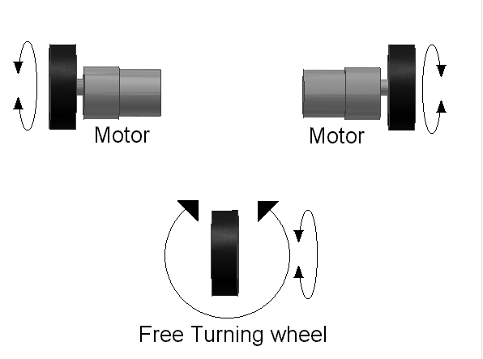

1. Attach spinning part of motors to wheels (2)
2. Attach side of motors to bottom rear of base
3. Attach spare office chair wheel to bottom front of base

Option B: Fully fledged drivetrain (more complicated but more effective)

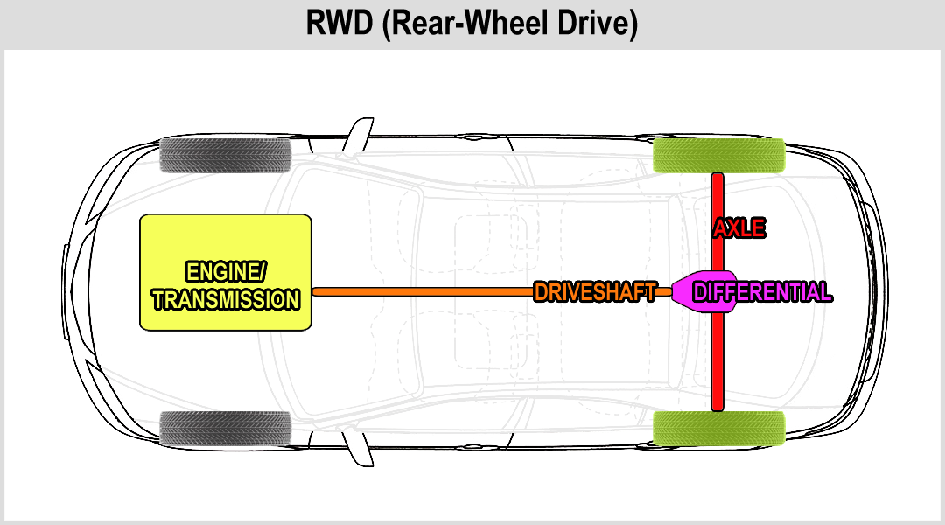

1. Driveshaft and differential required, and a power source. Possibly even brakes
2. Attach parts as shown

* Lifting Mechanism

1. Obtain small post lift
2. Attach side bottom of post lift to side of base
3. Attach arm base to liftable part of lift

Arm

* Base Joint

1. Obtain ball joint, swivel joint or something similar for omnidirectional movement

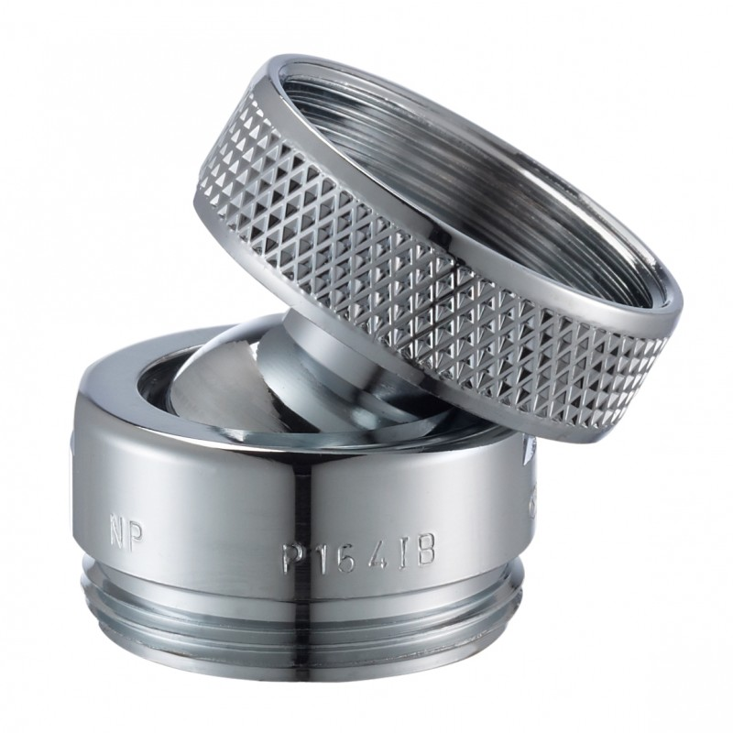Something like this

1. Weld joint end to bottom of arm

* Elbow Joint

1. Obtain hinge joint or something similar
2. Weld each end of hinge joint to each section’s tip of the arm

* Pistons (Pneumatics/Hydraulics)

1. Attach syringes to arm like so (attach metal cylinders to tips to extend use)

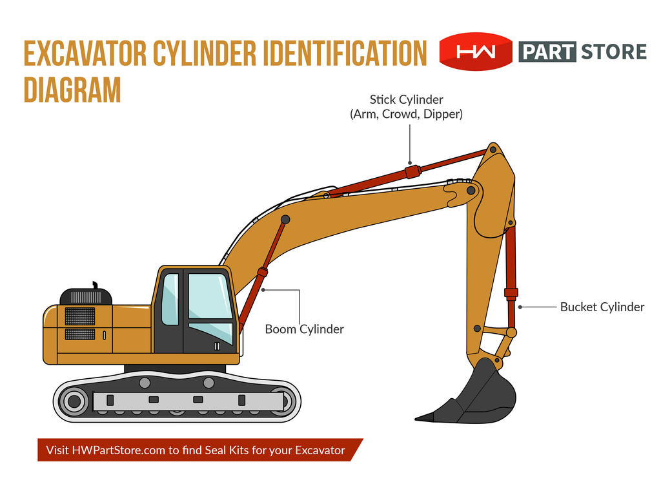

* Basic Material: Wood beam

Hand (We list the different components of the hand but a more detailed procedure will be in the electrical build procedure section)

* Wrist
  + Stepper motors - motors that divide a full rotation into an equal amount of steps
  + Stepper motor driver- used to control the stepper motors
  + Arduino Uno - single-board microcontroller that is the main control-unit of the wrist + CNC shield- used to interface the Arduino with the stepper motors
    - Flashing firmware
    - Communicating with the board
* Fingers
  + Small motors

Final Assembly

* Electronics
  + Converting electrical energy into kinetic energy
* Motion control (we’ll focus on that later)

*Final Assembly Procedure*

Here we explain how to assemble the different components (eg. base, arm, fingers) of the prototype together.

* Parts:
  + Wooden sticks/planks
  + Wires
  + Motors
  + Screws
  + Metal wires
  + Gears
  + Base plate
  + Rotation base and turret
  + Pins
* Assembly:
  + Form a rectangular shape using the wooden planks by cutting them with an electric powered saw.
    - Length: 6ft; Length at full extension: 10ft
  + Attach the motor to base plate. Making sure the wirings don’t get caught in between the base plate and the wooden rectangular block
  + Screw in the base plate with the motor into the rectangle
  + Attach the turret to the rotation base (cube will be able to rotation on a fixed base “plate”...lookup terminology):
  + Assemble the fingers:
    - Attach the ligaments of each finger, aligning pins at each of the joints
    - Using the metal wires, latch each ligament to each other
    - Take pins and insert into joints of each finger
      * Should look like:
        + 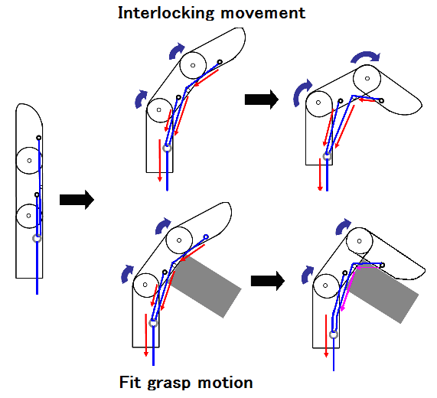
        + 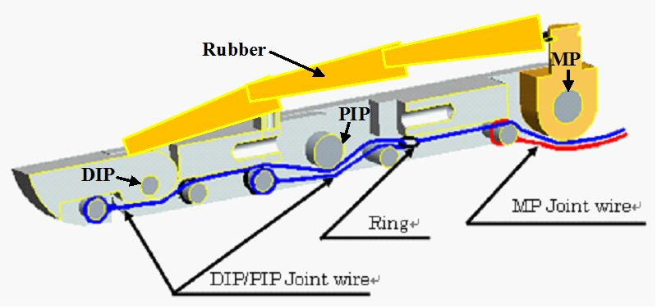
    - Take wire endings of finger and thread into each hole in the turret
      * Be sure to attach wires to internal motors as to not risk bending the wires
    - Threading wires into main wrist casing and attach to ports (insert specific ports)
    - Attach the turret with the main wrist mount plate

### Mechanical Arm Electrical Build Procedure

### This build procedure can be completed without any integration to the mechanical counterparts of the arm. We will break this up into sections and detail different options for certain parts of the procedure for different constraints.

### ***\*\*\*This is still very much a work in progress. Most of the procedure has been outlined, and will be finished as the project progresses. The complexity of some parts or options in the procedure will have lower priority but will be finished before the final project***`***

# **Section I: Materials**

### The following materials will be needed to construct and configure the electronic controls for the arm:

### - 1x Arduino/Genuino Uno R3 Board with ATMEGA328P Microcontroller Unit (MCU)

### - 3x A4988 Stepper Motor Driver Breakout

### - *3x 9mmx9mmx5mm Aluminum Heatsinks with Thermal Adhesive*

### - Breadboard

### - 3x NEMA 17 Stepper Motor (Any Variant)

### - Variable Power Supply (12-36V)

### - *22 Gauge Wire*

### -

### The following tools will be required during the construction of the apparatus:

### - Screwdriver (Phillips #0 and Flat #0)

### - Multimeter with CAT II Probes

### - Wire Cutters

### - Wire Strippers

### - Electrostatic Discharge Protection Wristband or Mat (Optional but recommended)

### - Math

### The following component datasheets will need to be used in this procedure

### - NEMA 17 Stepper Motor (Specific to ***your*** model)

### - A4988 Stepper Motor Driver (Optional, from specific Manufacturer)

### - ATMEGA328P Microcontroller (Optional, required for manual programming)

### Please note that any item italicized can be a generic part. This is important given some of the different specifications for different components.

# **Section II: Hardware Assembly**

## **Workspace Setup**

### - Before beginning any of the procedures, ensure the workspace is clean.

### o Dust, especially dust that has conductive properties can cause short circuits or undesired effects in any of the components.

### - The workspace must also be dry, and make sure any electrical outlets are properly protected and are clear from any water source.

### o When placing the variable power supply, put it in an area where it is unobstructed and easy to access. All dials and the main power switch must always be accessible during the procedure

### o Ensure that the variable power supply is set to the input voltage of your electrical outlets. Ask your local electricity provider if you are unsure

### - Ensure that the area is well-ventilated and at room temperature.

### - As you progress through this procedure, keeping organized is highly recommended.

### o Ensure that Stepper Motor Wires are contained or controlled in some form, as they are easily tangled with other wires

### o Tools should be set aside in a designated area to allow for maximum efficiency

## **Arduino Setup**

### This step is only if you purchased the Arduino Board and the MCU separately. If your Arduino is purchased and has the MCU in the proper socket, skip to the next segment of the procedure.

### Please also not that if you are unable to connect the Arduino Board via USB to the computer, then manual programming is available. See Via AVRDUDE for more details.

### 1. Once the Arduino is unwrapped, look for a notch on the MCU Socket, as shown in Figure 1

### 2. The MCU should also have a notch indication determining the location of the first pin.

## **Breadboard Wiring**

### The basis for the breadboard wiring is recreating this general schematic provided by the driver manufacturer, Pololu, but done multiple times in parallel with different targets.

### Source: 1)<https://a.pololu-files.com/picture/0J10073.1200.jpg>

### Before we begin breadboarding, a few things need to be acknowledged, using the diagram below as a reference:

|  |
| --- |
| 1. The vertical regions on the side |

#### **Extending the Stepper Driver Cables**

### Throughout the assembly process, you may find that the overall length of the cable given by the stepper driver is not consistent across all individual leads or that the integrity of the jumper cable is lost. As a solution to this problem, a simple protoboard/breadboard that uses screw terminals can be used

## **Stepper Driver Configuration**

### This segment of the procedures describes the steps to properly configure the power limit on the Stepper Motor Drivers and other necessary steps. This video should help with properly performing the necessary

### **Wiper Configuration**

### The wiper is the screw-head potentiometer that is centered as the top of the board as shown below

# **Section III: Flashing the Firmware**

### Firmware is critical for allowing the Microcontroller Unit (MCU) on the Arduino to properly communicate with the computer and maintain control with the motors. Because there are two ways to perform this procedure, both will be listed.

## **Via AVRDUDE**

### **AVR D**ownloader and **U**ploa**de**r is an open source program used by the Arduino IDE to upload firmware to the MCU. This method is much more complicated and should only be used if the MCU (usually the Standard ATMEGA328P) is unable to be programmed through the standard Arduino Bootloader or by USB.

### *\*\*\*This segment will be completed later because of the complexity of the operation overall and that any incorrect instructions can permanently damage materials.\*\*\**

### 

## **Building from Source**

### If you have any intention of making any modifications to the firmware, I have licensed the code to be open source, and it can be downloaded from Gtih

# 

# **Section IV: Establishing Communications**

### Assuming all previous steps have been followed correctly, the board should be setup for operation. However, the board is dependent on signals from an external device to function, hence why this section is written.

## **Some Notes**

### Regardless of the method, some settings will remain the same. The COM Port will be set by the computer and found different ways depending on your operating system. The Arduino IDE will automatically tell you which COM port to

### The baud rate (how much data is sent in a single time frame) is 115200 baud. If any serial output displayed is corrupted or there is unusual behavior exhibited by the controller, check if the baud rate is set correctly.

### 

## **Using a GUI**

### With this project, I have modified an open source program made to work with CNC machinery called Universal G-Code Sender.

### 

## **Using a Serial Terminal**

### The other option for controlling the stepper motors is through the firmware’s built-in serial communication interface. This option is covered by the GUI option, but this section will detail how to establish communication using a different program. The GRBL firmware documentation is very helpful and will help with understanding how to operate the terminal.

### You have two options for communicating through a serial terminal. The first option is the Arduino IDE’s built-in serial monitor and is the easiest option. The other option is to use PuTTY, a terminal program capable of communicating with serial. Both options will be displayed but operation through the terminal is covered by the GRBL documentation.

### 

### **Using the Arduino IDE**

### Once you have the proper board and port selected in the Arduino IDE (covered in [Subsection to Flashing the Firmware]), Serial communication is very easy. This is very similar to the serial terminal method, and requires you to understand the GRBL command line sender to properly operate. This is highly unlikely that you will use this method, but

### 1.

### 

**Drawing and Pictures of Prototype**

In this section we displayed a working drawing and pictures of our prototype. Using images, we were able to show more clearly what our prototype looks like, making our project more visually appealing. (Note: We had only finished constructing the two parts of the arm, the elbow joint (the circular rod), wrist joint (fidget spinner looking thing), and finger joints. Due to technical difficulties with the 3D printer and Period 6 sabotaging it, we were not able to finish the rest of the prototype at the due date of this element).

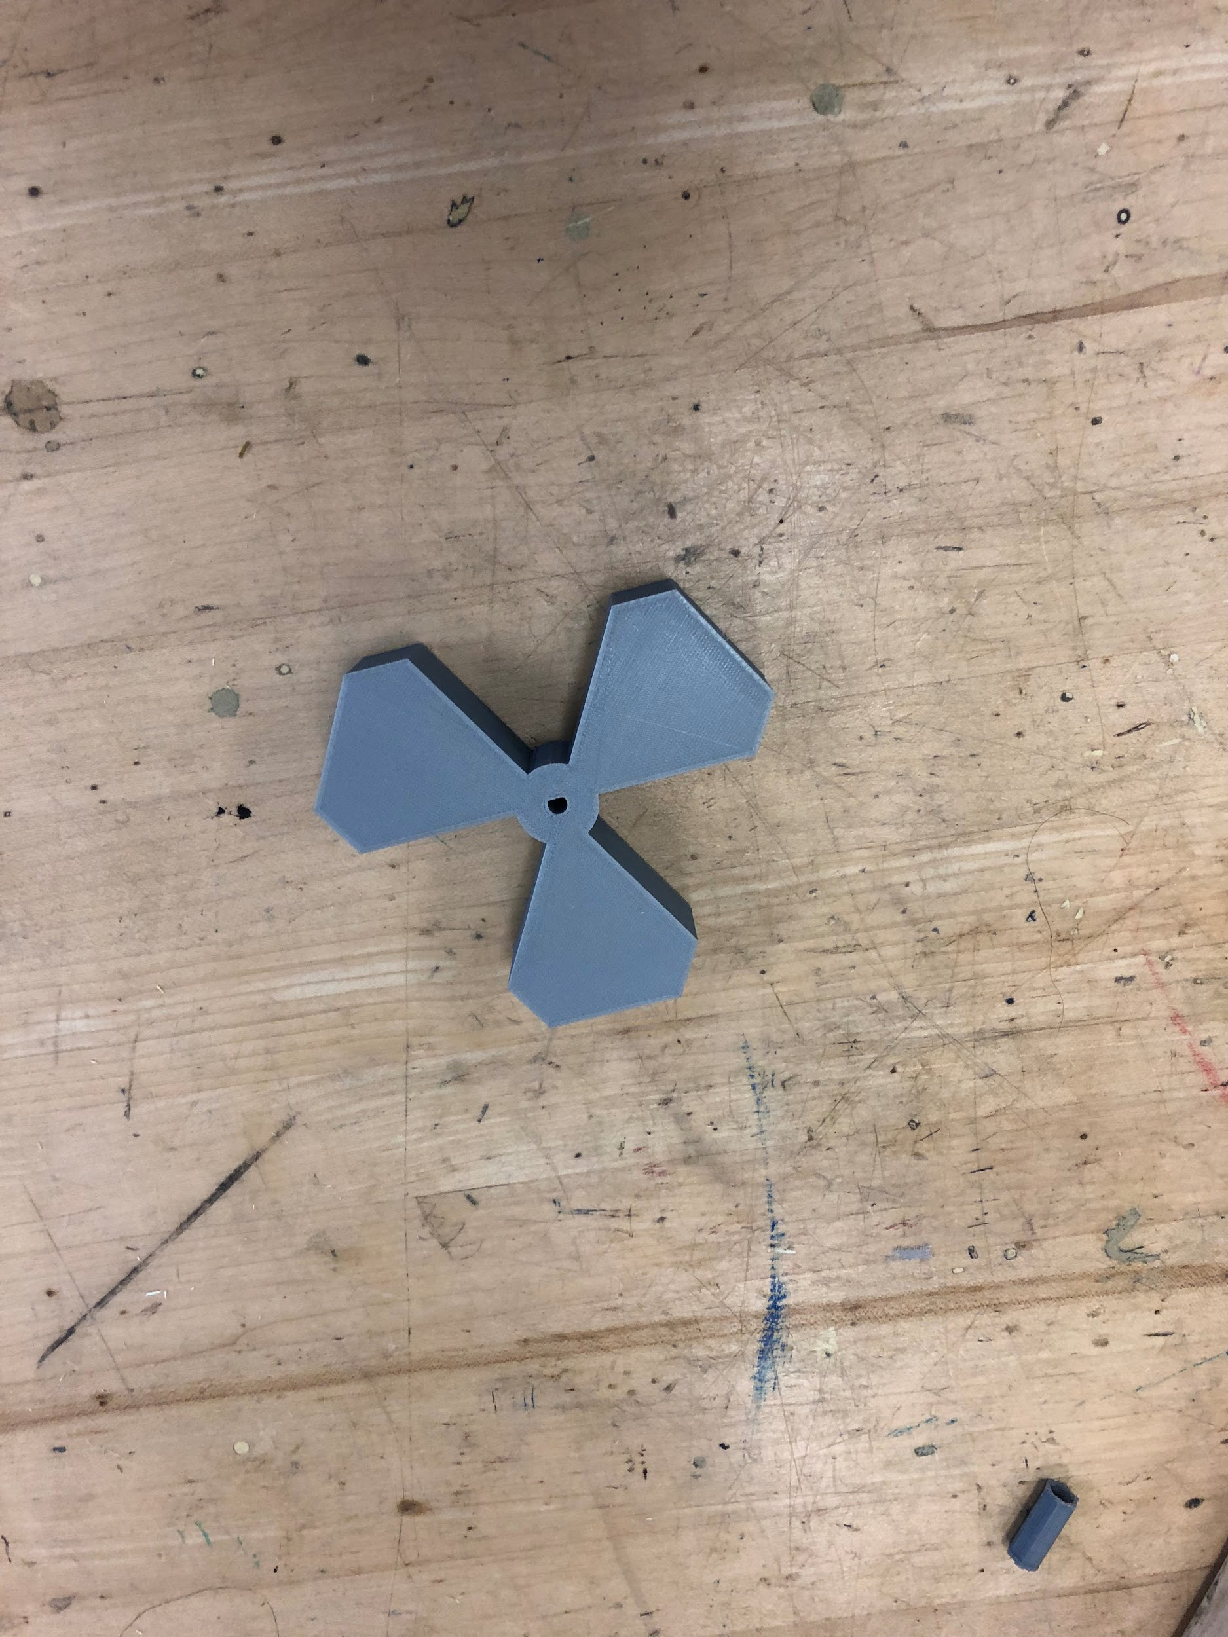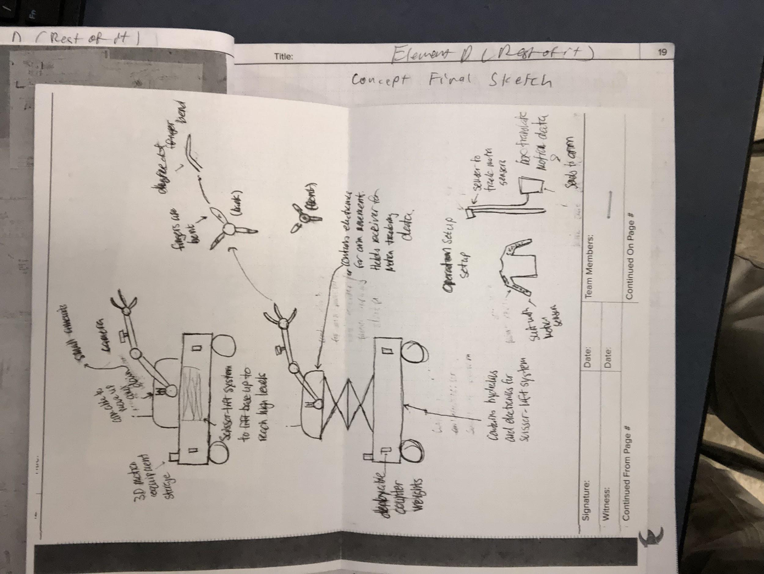

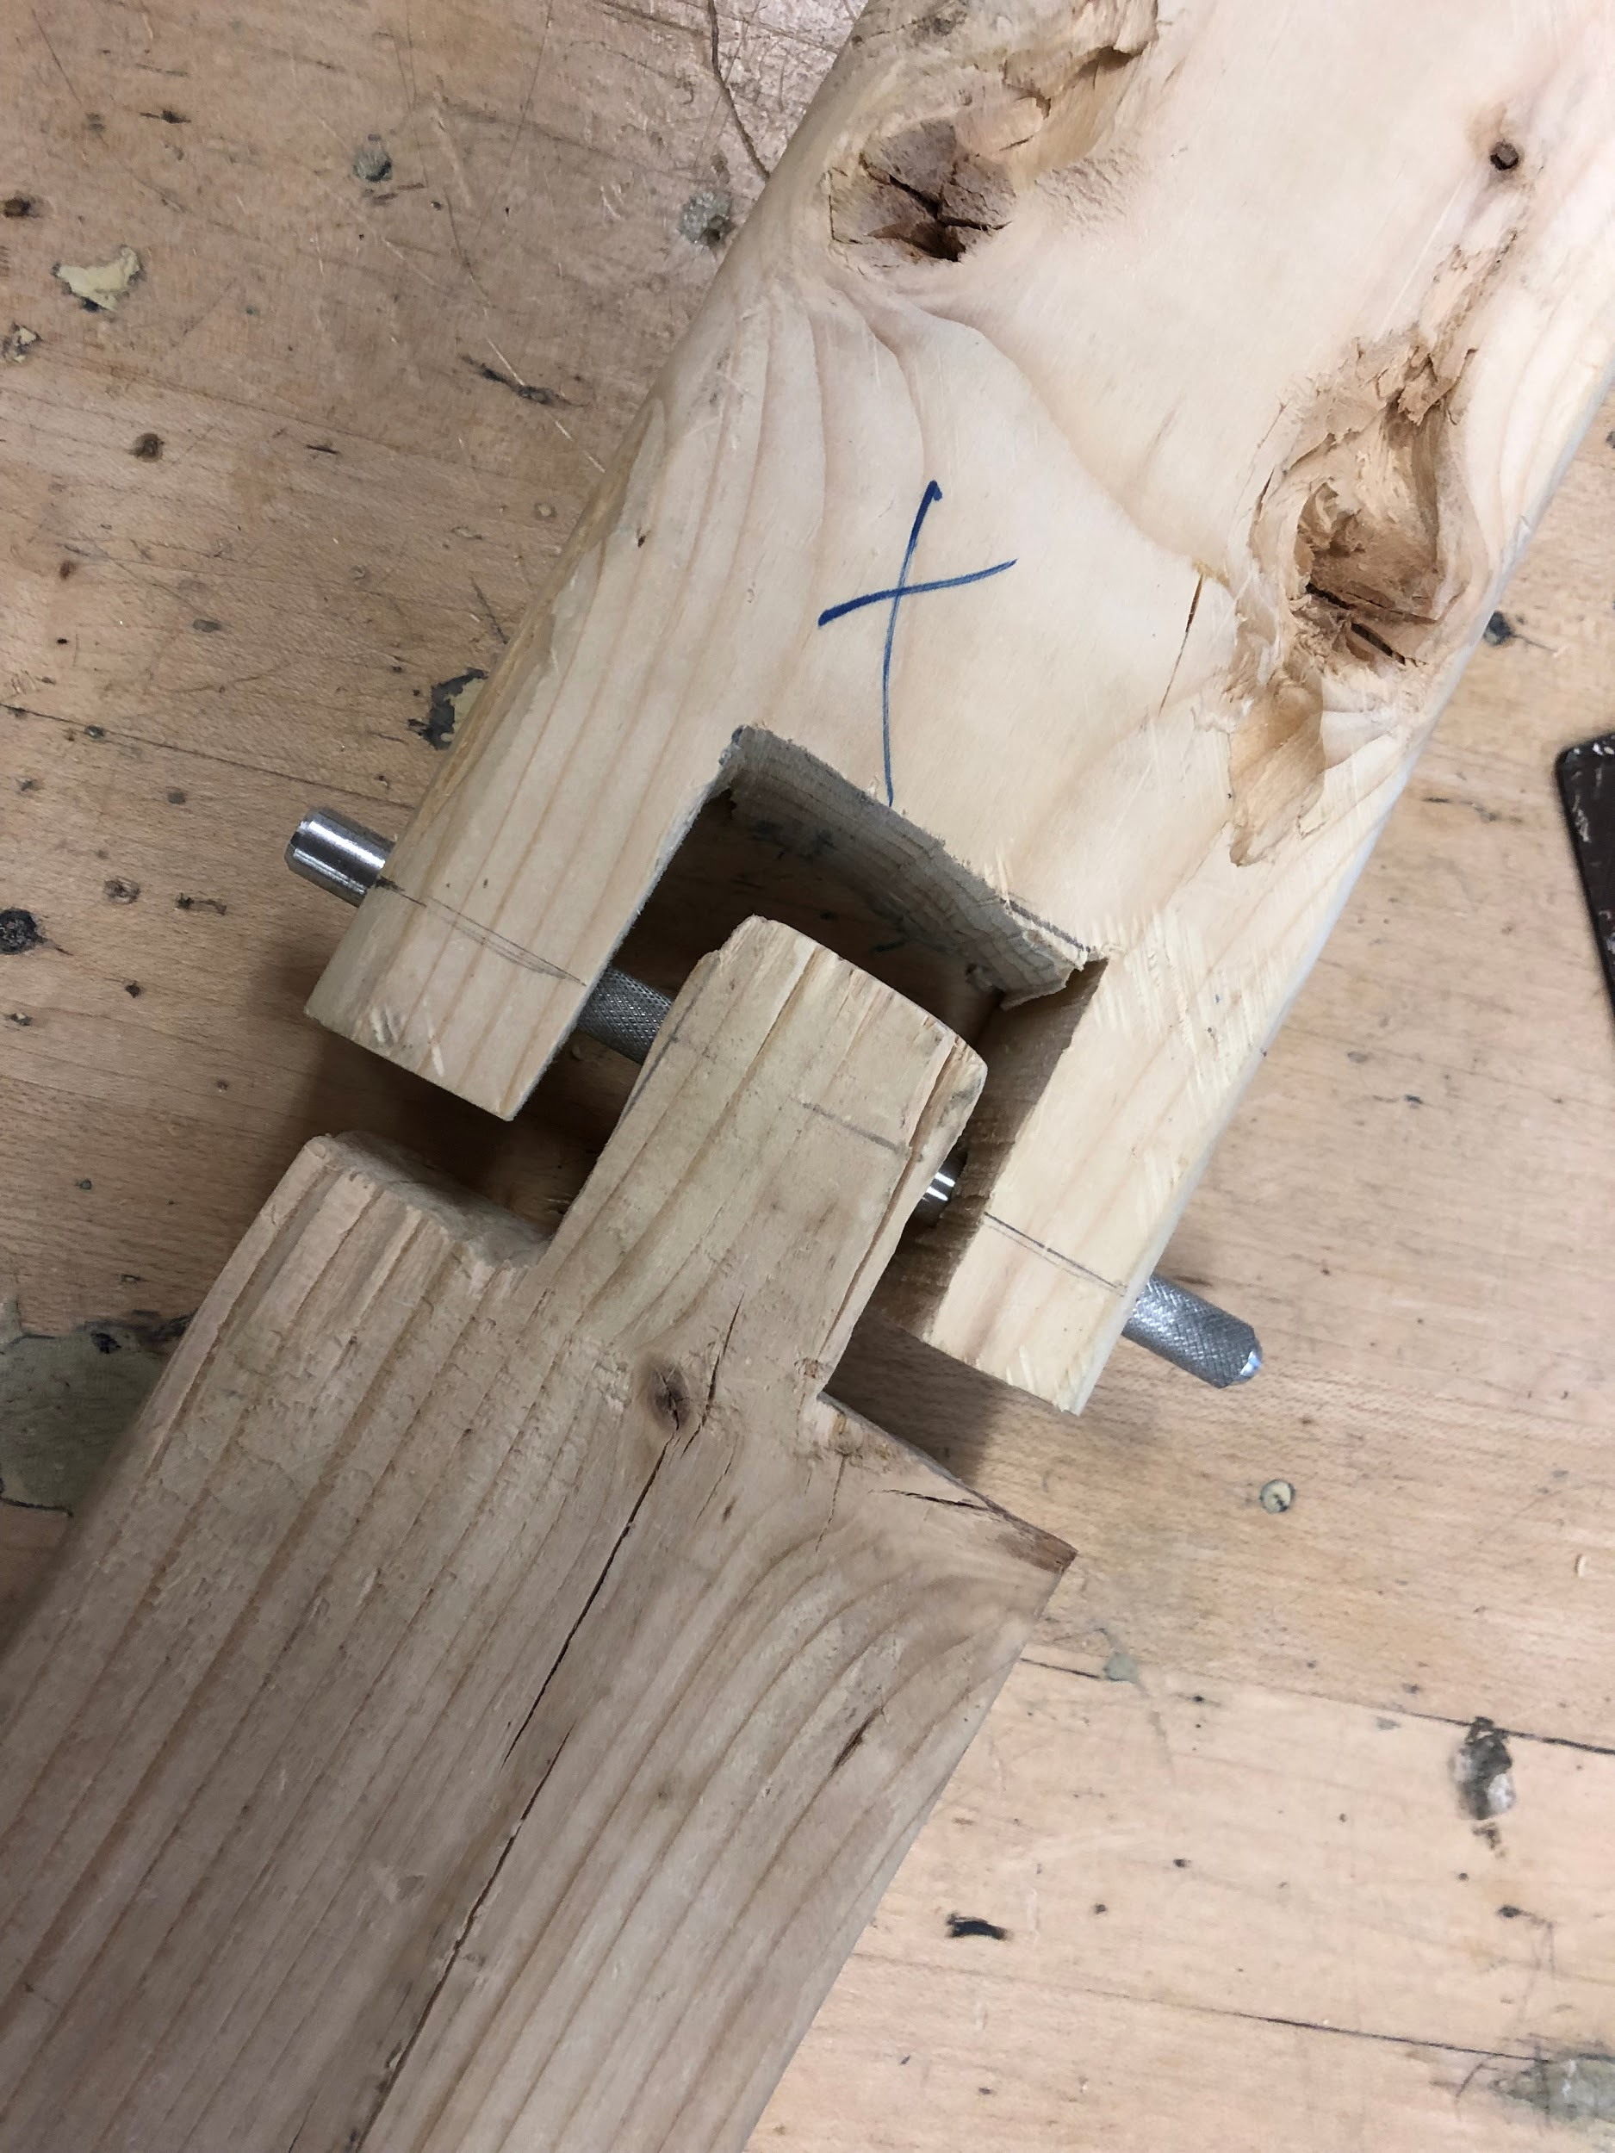

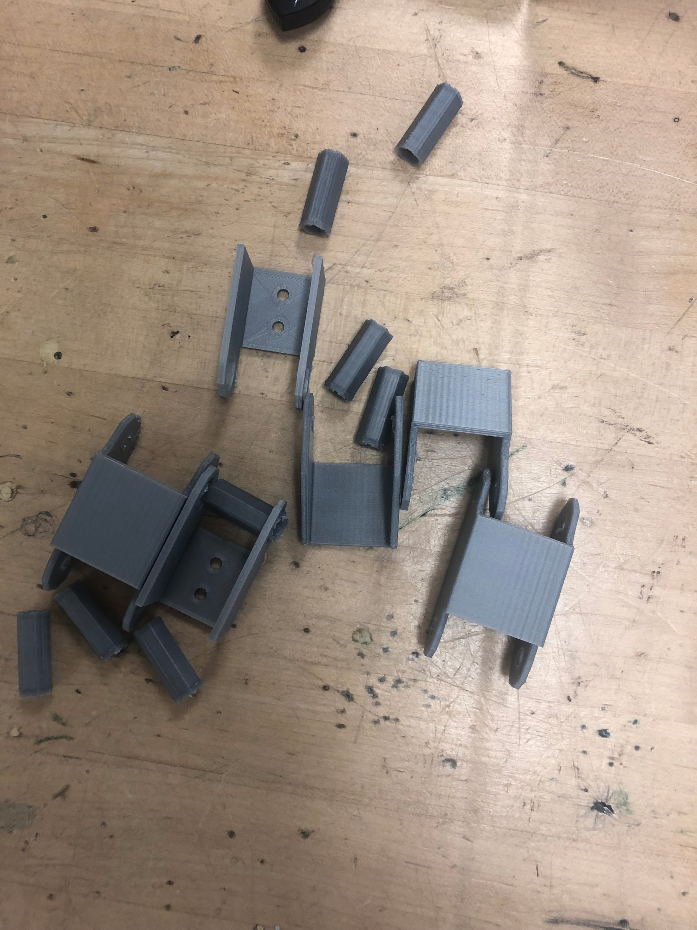

**Documentation of Building Process**

It is not enough to just write our the building procedure, but we have to show its execution. We documented the different steps we took to construct the prototype by recording them in our engineering notebook.

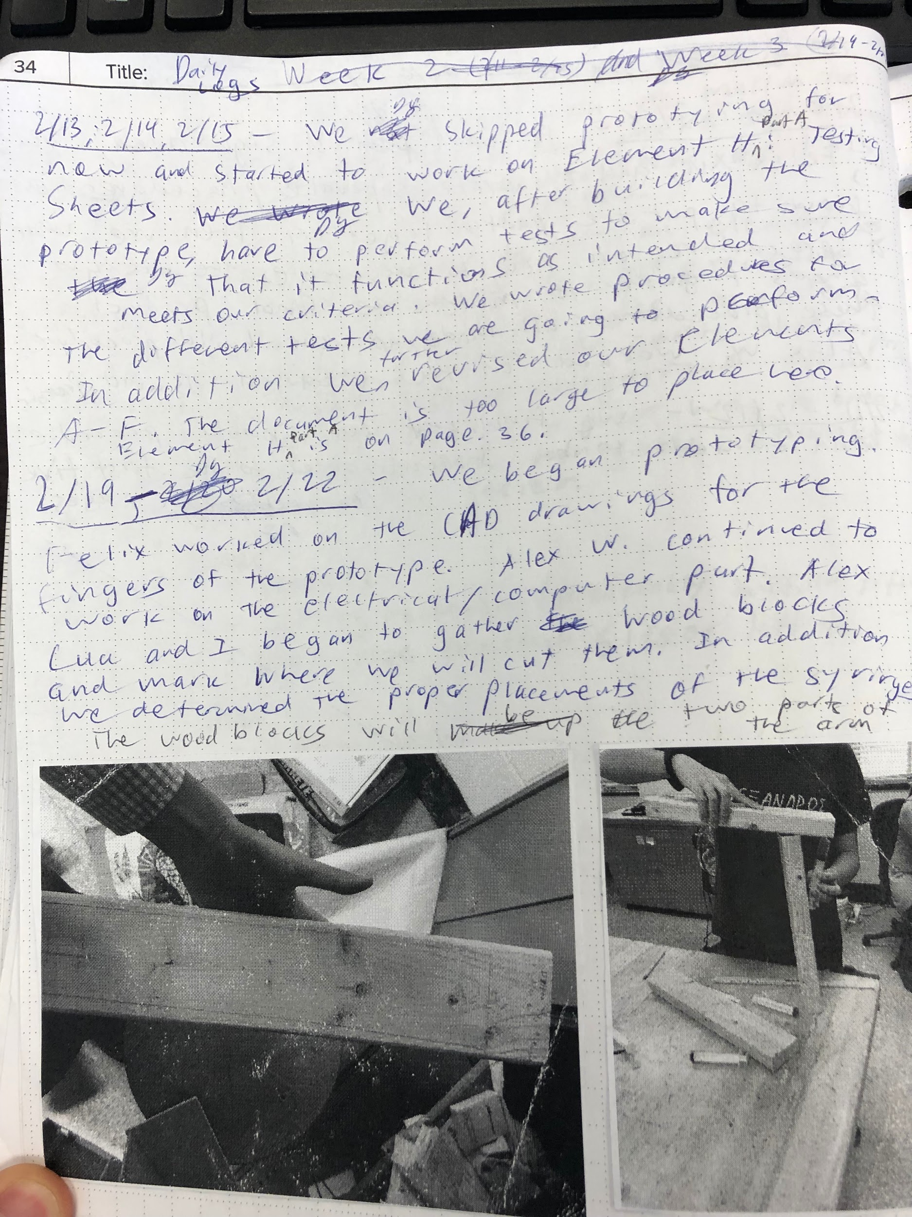

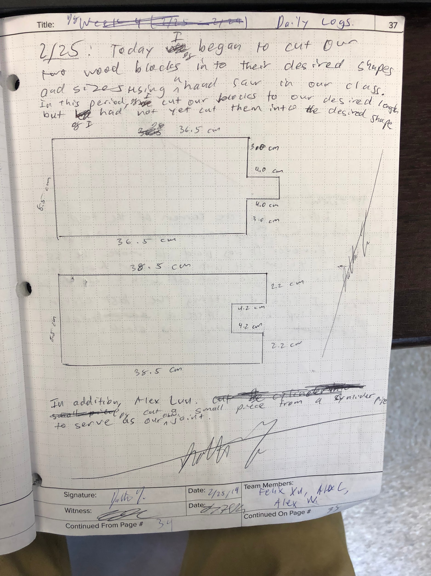

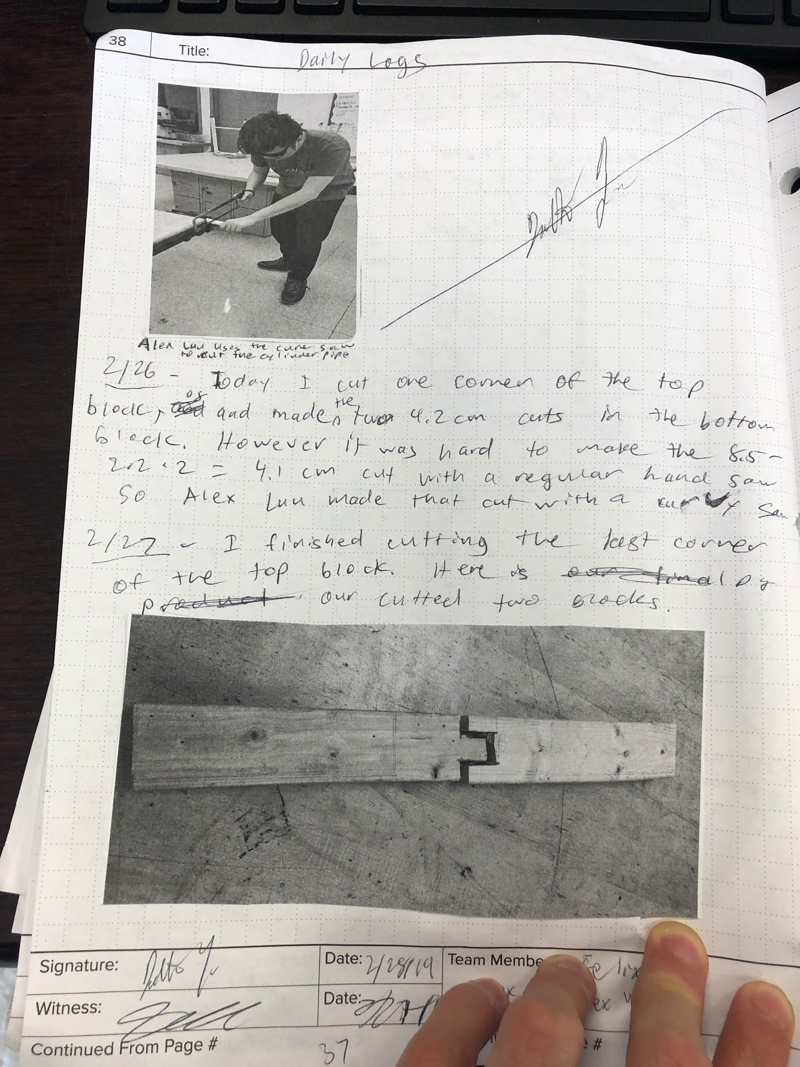

**Correspondence with Identified Expert/Craftsman**

We collaborated with experts and craftsmen to help us construct and test features of our project that we couldn’t do on our own. In the correspondence log below we showed email messages we sent to them.



**Correspondence Log**

**Instructions**

Keep the first table as a template. Copy and paste the template as additional entries are needed.

|  |  |
| --- | --- |
| 2/24/19 | Correspondence Notes / Email Transcripts |
| Mr. Pope showed our group how to use the hand saw to cut wood efficiently and safely. He showed me the positions to put our wood when making the different cuts. |
| Contact: |
| Kevin Pope |
| Contact Title: |
| Engineering teacher at Walt Whitman high school |
| Contact Information: |
| Kevin_E_Pope@mcpsmd.org |
| Subject: |
| Cut wood for EDD project |
| Follow-up Required - Date | Action Items |
| 2/25/19 | Meet him next day in EDD room, where he will show me how to use the saw to cut the wood. |

|  |  |
| --- | --- |
| 3/9/19 | Correspondence Notes / Email Transcripts |
| I emailed him our Innovation Portal for him to critique. Then we scheduled a meeting date (4/4) with him at Whitman, where he gave us great suggestions on construction of our prototype. See Element J and our engineering notebooks for more information. |
| Contact: |
| Gary Davis |
| Contact Title: |
| NASA Systems engineer at Goddard Space center |
| Contact Information: |
| gary.t.davis@nasa.gov |
| Subject: |
| Expert for engineering design project |
| Follow-up Required - Date | Action Items |
| 3/18/19, 4/4/19 | Respond to his reply, meet him at Whitman |

|  |  |
| --- | --- |
| 4/3/19 | Correspondence Notes / Email Transcripts |
|  |
| Contact: |
| David Smith |
| Contact Title: |
| Vice president of Alpine Engineering and Design |
| Contact Information: |
| dsmith@alpineeng.com |
| Subject: |
| Expert for forklift safety |
| Follow-up Required - Date | Action Items |
| 2/25/19 | None, just use his advice to improve our innovation portal |

**Programming Documentation**

**All of the code has been written by Alex Westerman. The code is open sourced and available at** [**https://github.com/FaceFTW/Armanipulator**](https://github.com/FaceFTW/Armanipulator)**. Below is a copy of the generated documentation (better formatting available at** [**https://github.com/FaceFTW/Armanipulator/blob/doxygen/Armanipulator_Firmware/docs/rtf/refman.pdf**](https://github.com/FaceFTW/Armanipulator/blob/doxygen/Armanipulator_Firmware/docs/rtf/refman.pdf)**):**

**Summary of Element G**

Thus in this element, we wrote the build procedure for our prototype, began to construct it, and communicated with our experts to help us with attributes we cannot build and test. We learned that planning is incredibly helpful because without the build procedure we wouldn’t have been able to begin construction. We also learned that building is not a one size fits it all process; one will have to make changes or use different methods along the way. For example, we had to use a curvy saw to make a cut that a regular hand saw wasn’t able to do. Overall, this building process was very valuable.

**Element H: Prototype Testing, Data Collection Plan, and Testing Analysis**

In this element we created procedures and data collection charts for the different tests we plan to conduct on the prototype to see if it meets our design requirements. These tests contain the elements of physical and mathematical modeling that we have learned about in class, making them well- justified. In addition to testing procedures and data sheets, we made hypotheses of what will happen with each test when we conduct it.

**Testing Sheets/Procedure (Note: Follow the safety concerns strictly. Safety is first in any experiment! )**

These testing sheets are the blueprints for our tests. Each test includes the materials needed, safety precautions, testing collection charts, procedures, and a pass-fail criteria to assess whether it has succeeded.

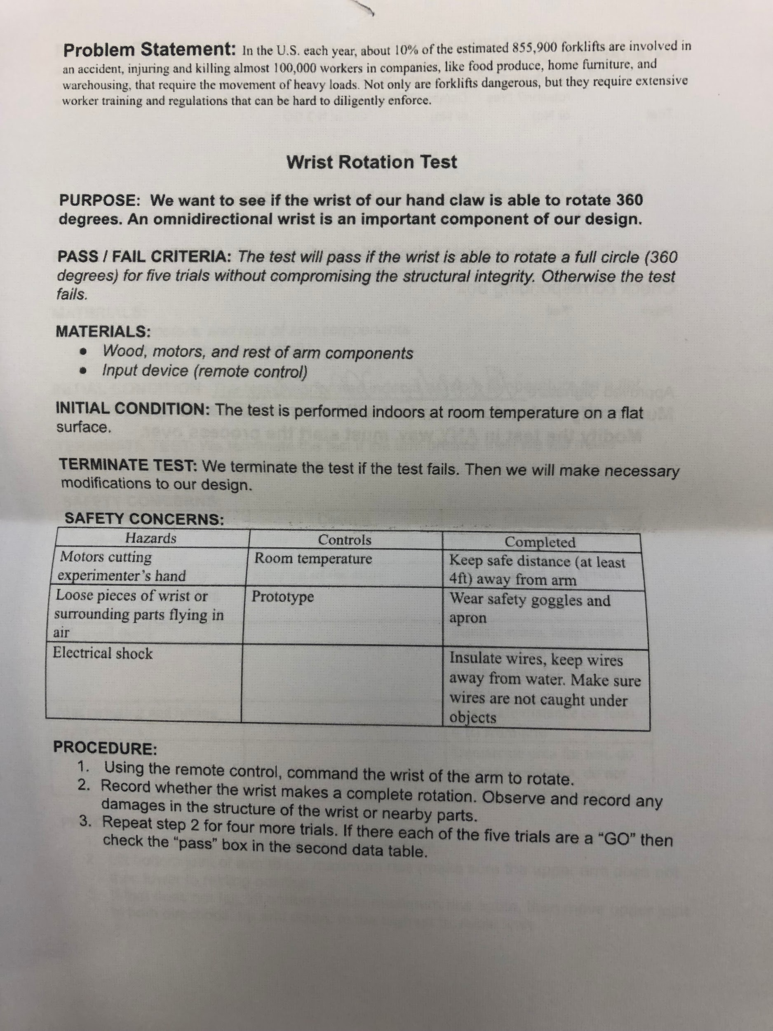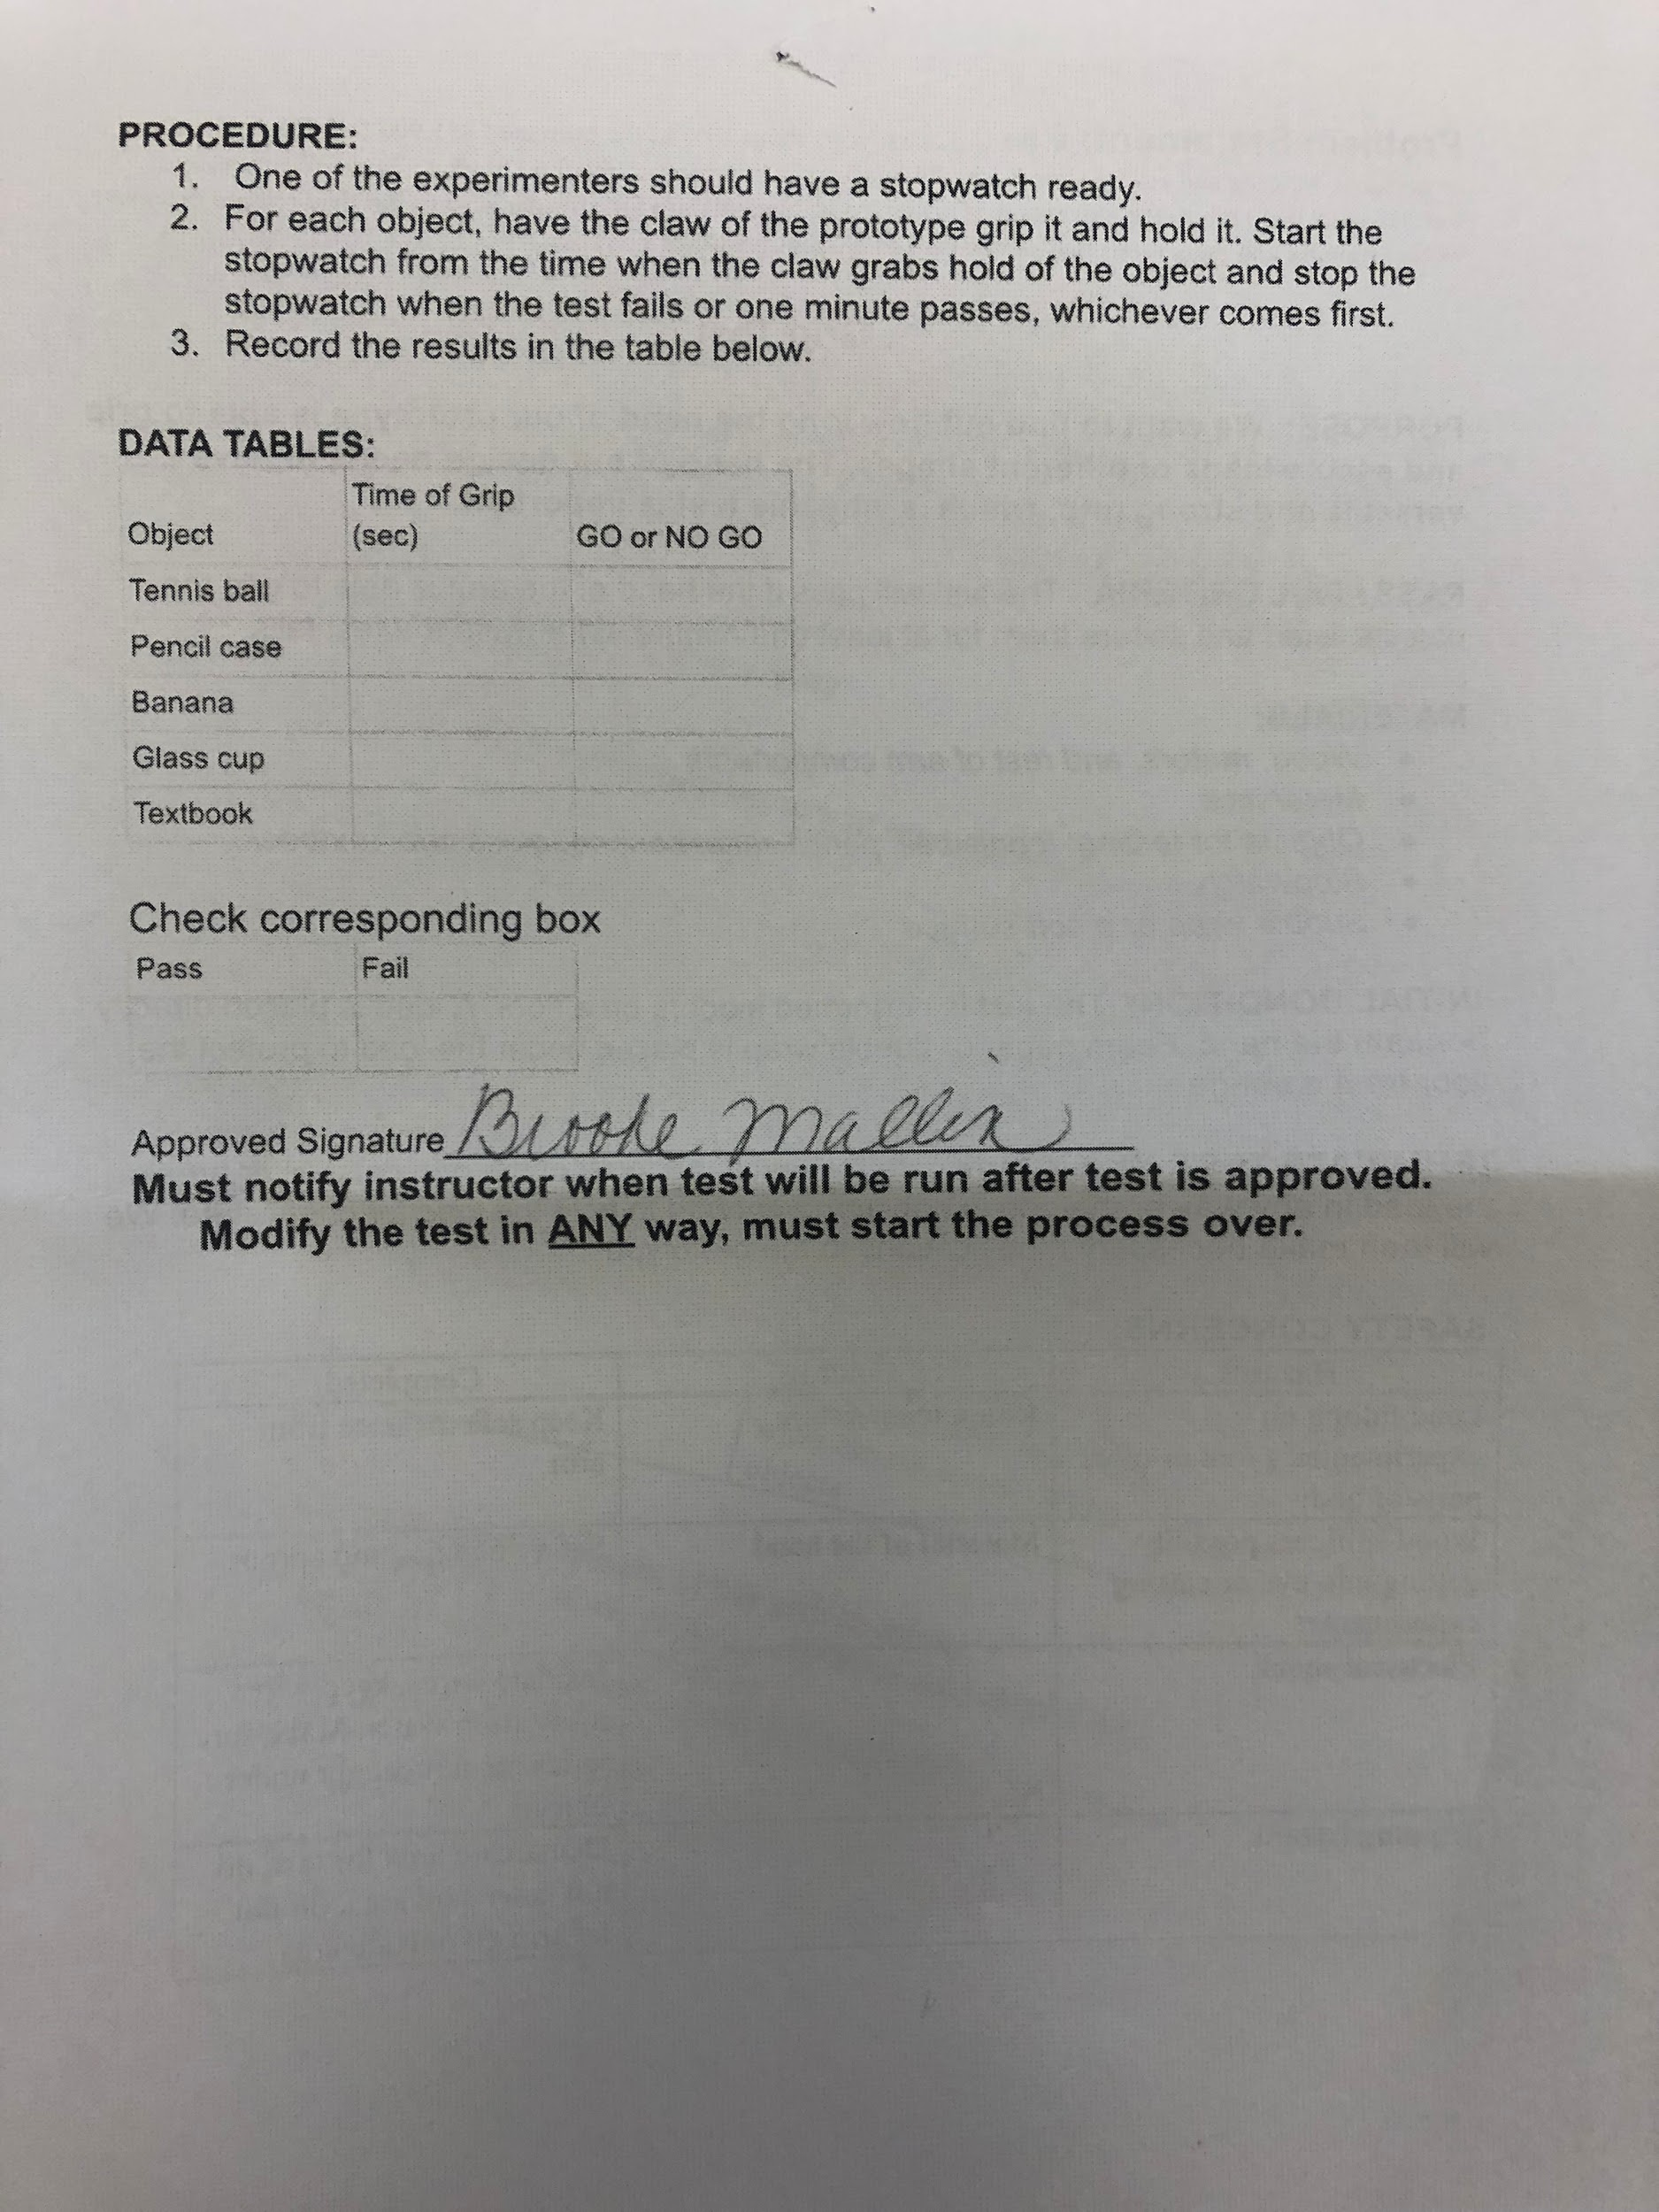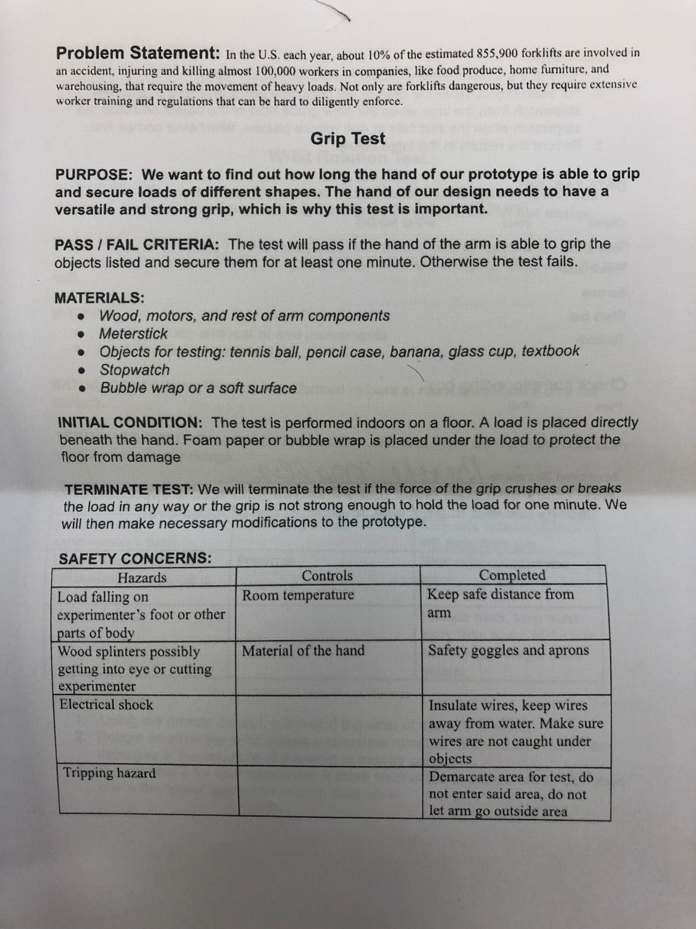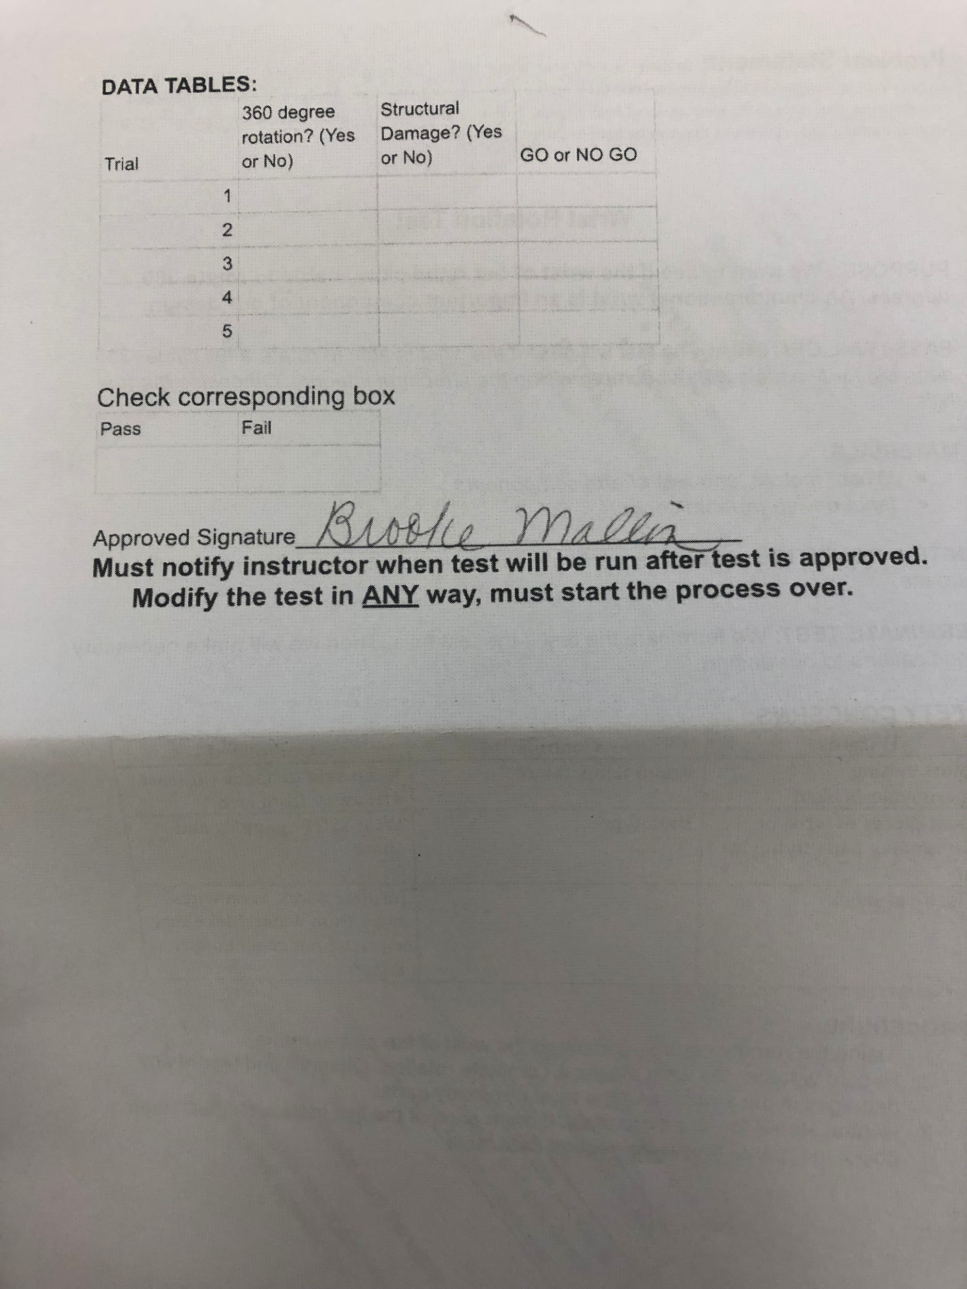

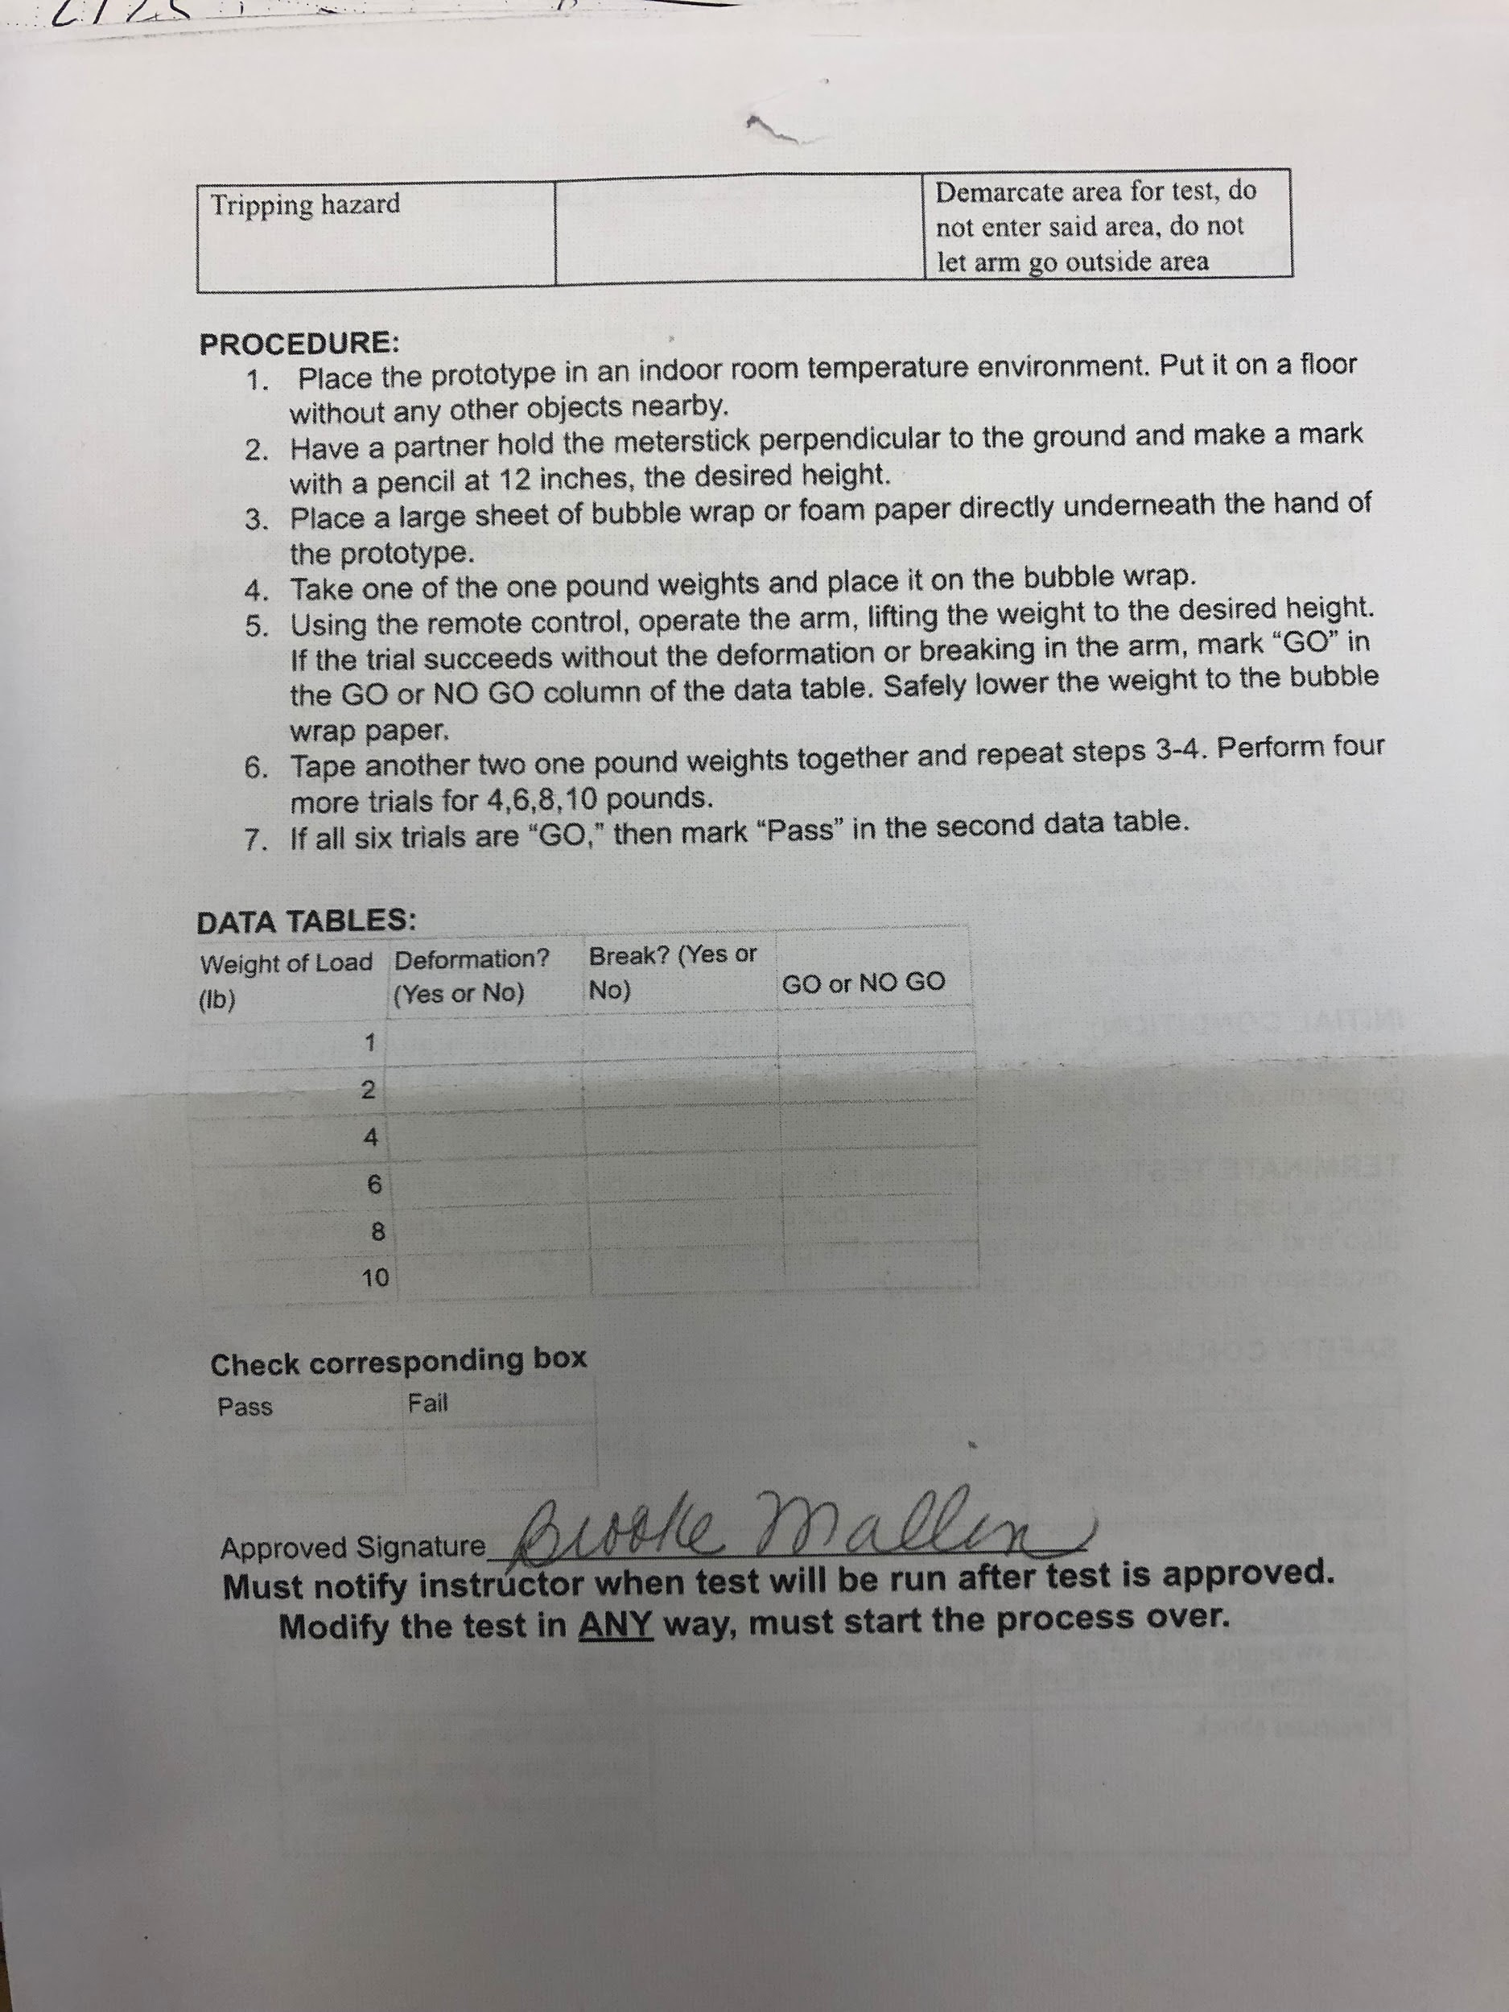

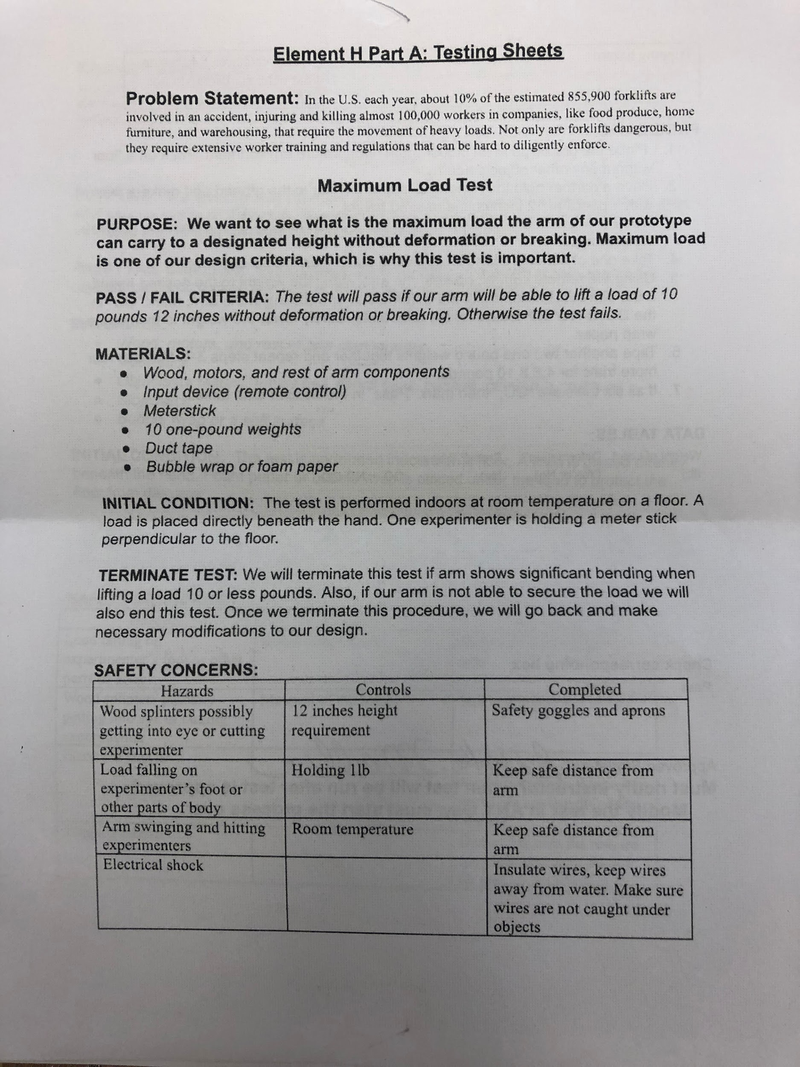

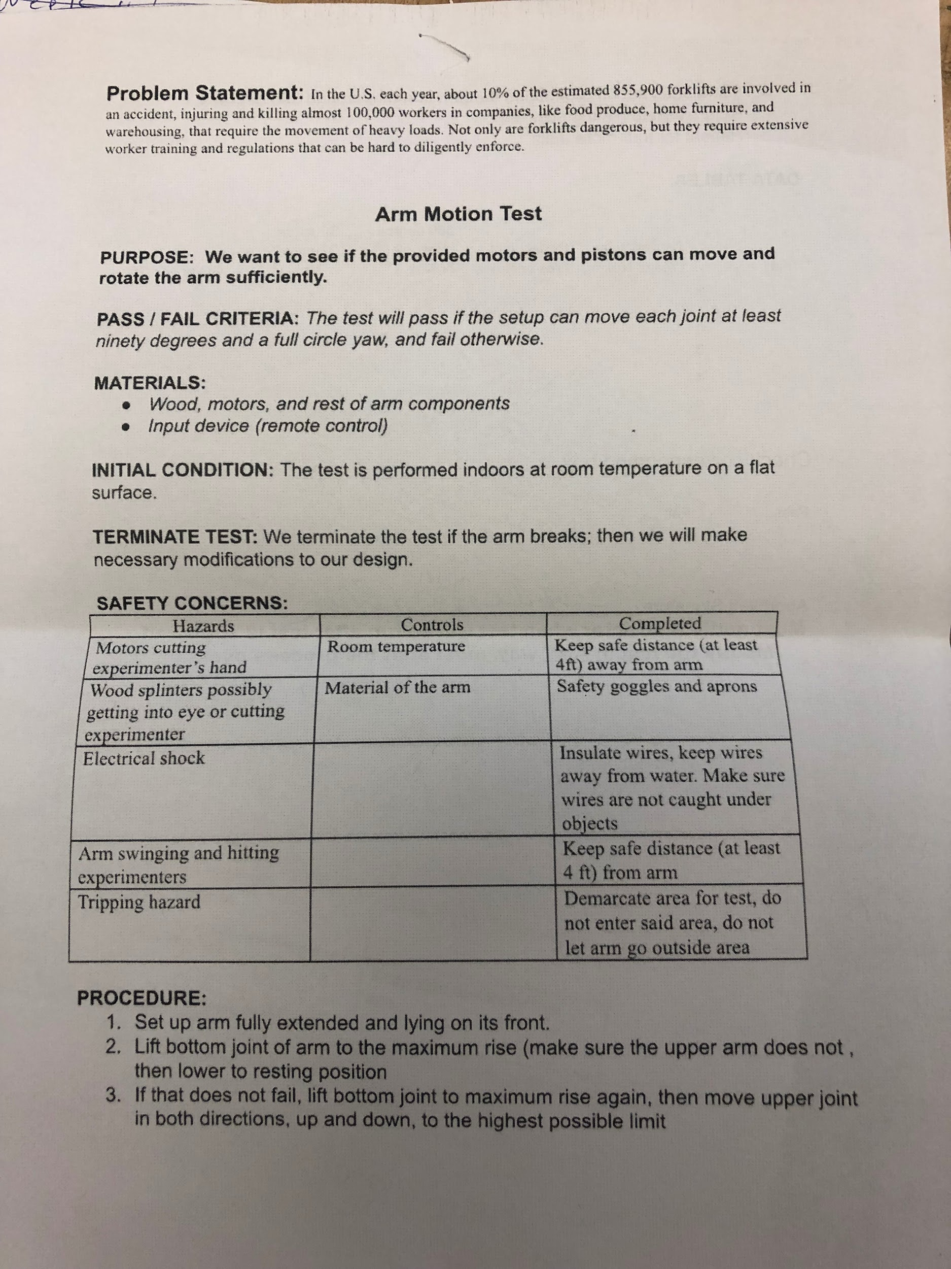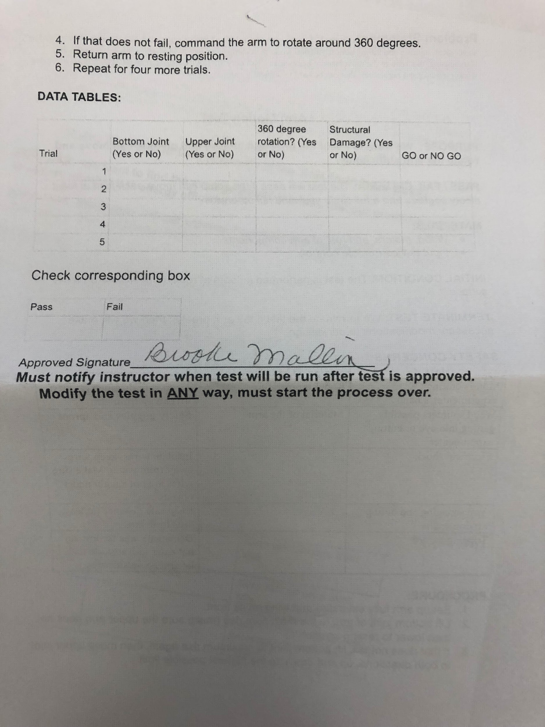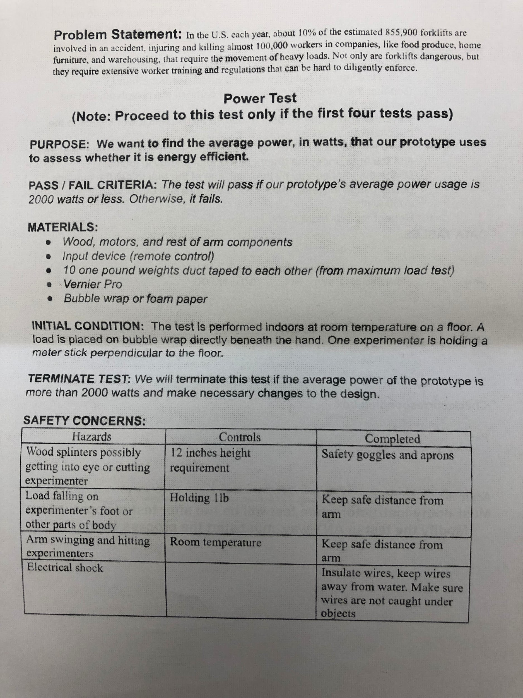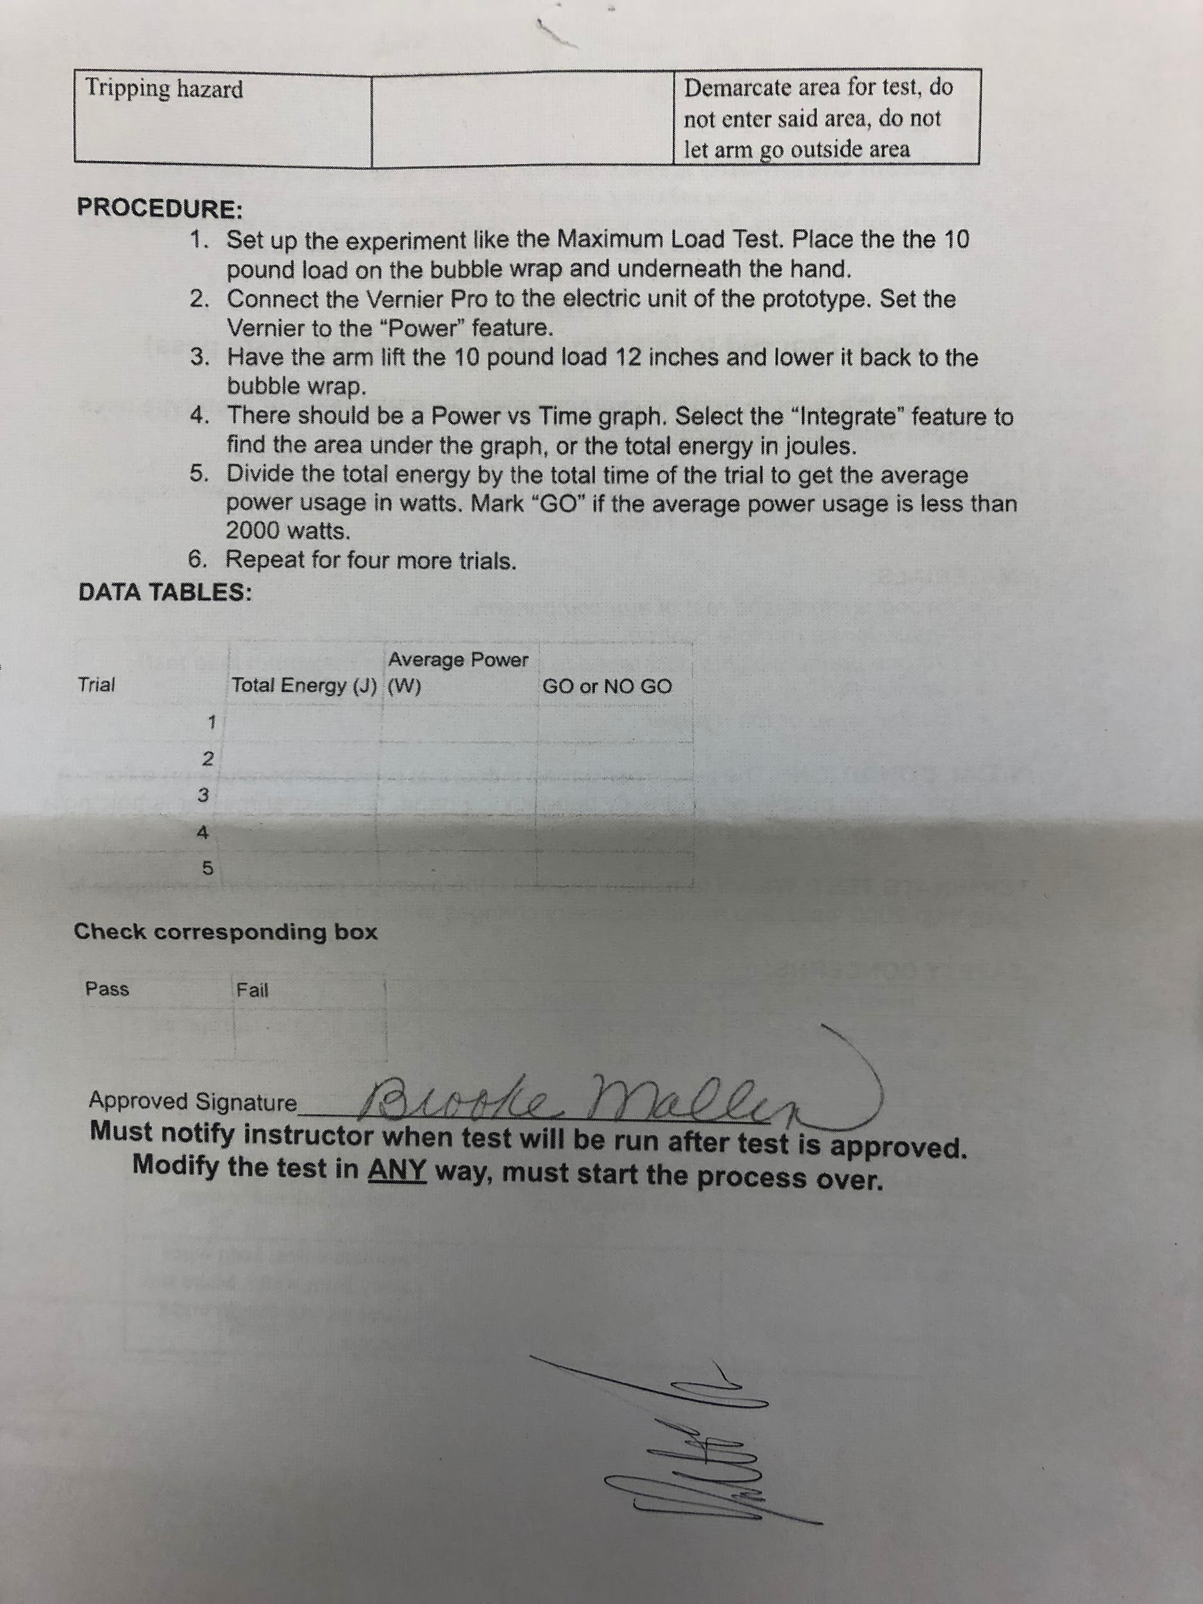**Hypotheses**

These are our predictions of what will happen with each test we conduct. In this section we assess whether the test will pass and fail, and if fail, then when it will fail. Through this hypotheses, we will know what to expect and have an idea of what future modifications to make. (Note: We have not finished the entire prototype so these are just “rough” hypotheses).

Maximum Load Test: We predict that our prototype will be able to lift about 5-7 pounds. 8-10 pound is a little questionable given the tensile strength of our wooden block.

Grip Test: We will probably have trouble gripping the banana due to irregular shape and the textbook due to wide area.

Wrist Rotation: Given that there are no malfunctions in the stepper motor and problems in our code, we believe that the the wrist rotation test will pass.

Arm rotation : We also believe the arm rotation test will pass because our elbow joint right now is pretty flexible and we think that the lower arm joint will be the same.

Power: We think the prototype is going to pass this test because we don’t think the power usage is going to exceed 2000 watts, the approximate power usage of a fan heater.

**Summary of Element H:**

Thus, in this element, we created testing sheets that contain our test procedure, safety precautions, materials needed, and data collection charts. We also predicted what will happen will test. These testing sheets were valuable because they provided an orderly plan-of-action for us.

**Element I: Testing, Data Collection, and Analysis**

In this element we displayed the data collected from our tests. Then we reflected on the data, including our personal comments on whether the data met our design requirements. We also asked experts to comment or critique on our data to yield a reliable analysis on its effectiveness.

Unfortunately we have not finished our prototype so we are not able to complete this element. The groups in Period 6 who use the printer keep disrupting the print process. When they use it, they break it in some way, which screws up our prints and delays construction. We have finished with the majority of the arm of our prototype, but all of our tests can only be performed with the whole prototype. We have tried our best to meet this deadline but we physically cannot do it because of these limitations.

**Element J: Reflection on the Design Project**

After finishing conducting our tests for the prototype, we proceeded to element J. It is important that we, as the designers and builders, get constructive feedback from our qualified experts and stakeholders on our project. Using the comments, opinions, and questions from our experts, we reflected on our design project, detailing what we did well and where we can improve on before jury day. Below we documented the feedback our experts gave us via photos and organized the feedback into categories. Then we analyzed each piece of feedback in a short paragraph.

**Expert 1: Gary Davis (Systems engineer at NASA Goddard Flight and Space Center in Greenbelt, MD)**

**Compliments:** 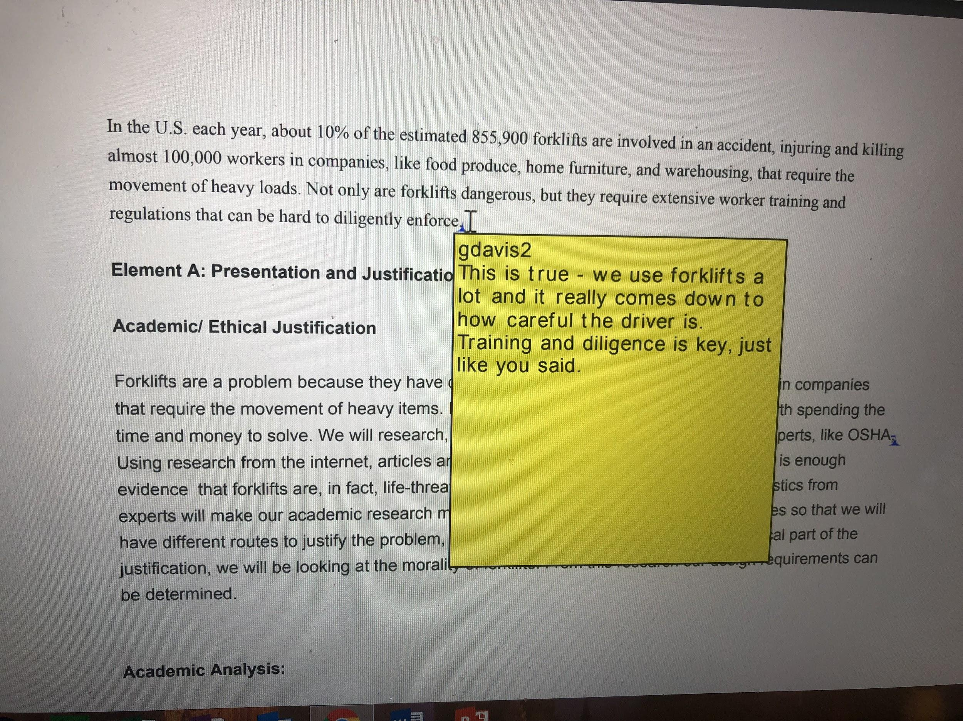

Mr. Davis likes our problem because it is prevalent in all different work settings, like NASA. He agrees that there is a lot of training needed and that an inexperienced person could risk his life or the lives of others. He believes the problem is justifiable.

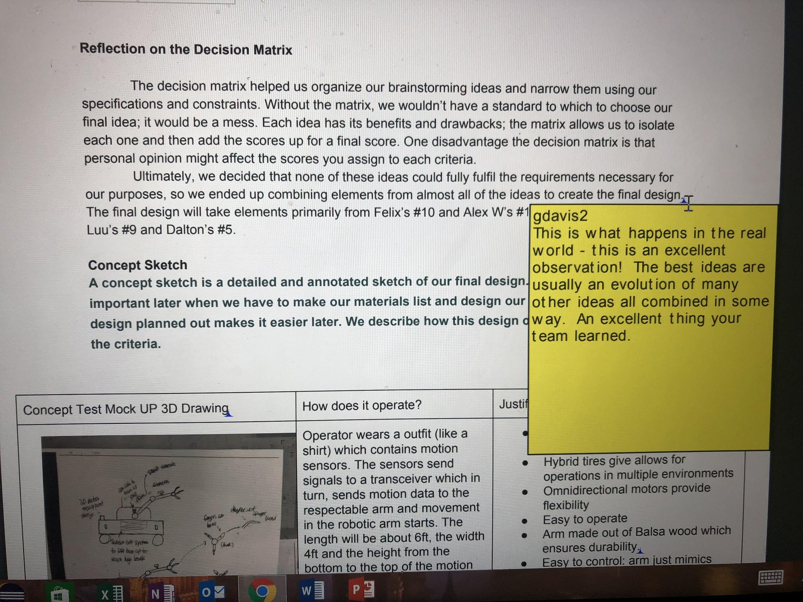

Mr. Davis also likes the valuable things we learned from the decision matrix, like combining different ideas to make our final design. We did a good job of using engineering principles to help facilitate the design process.

**Criticisms:**

We said that “forklift accidents kill 85 people,34900 incur serious injuries.” Mr. Davis wants to know if this is the most serious cause for workplace accidents, which would further justify this problem. We need to conduct more research on workplace accidents in U.S to address this. 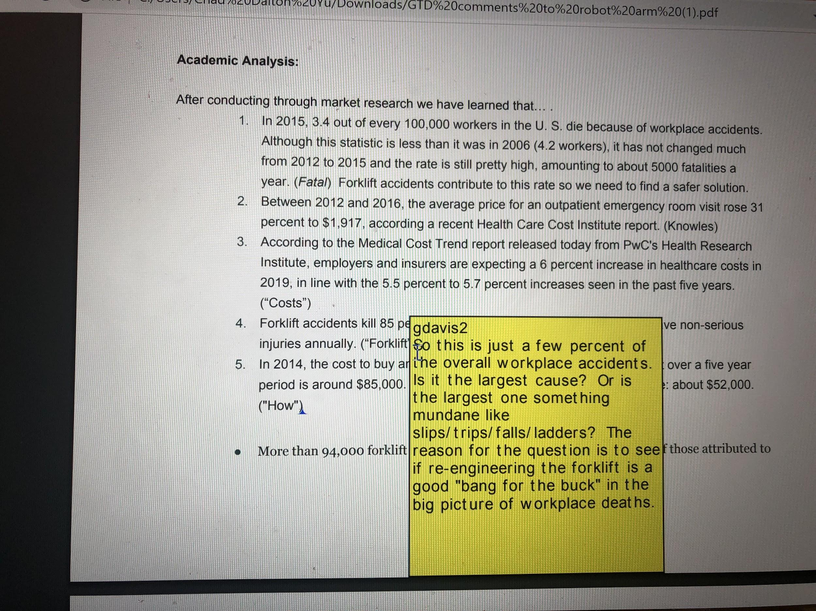

In our survey we only had two responses, which is not enough to make a conclusion. Therefore we will find ways to obtain more responses (ie forums, department stores) to make our research more sound. 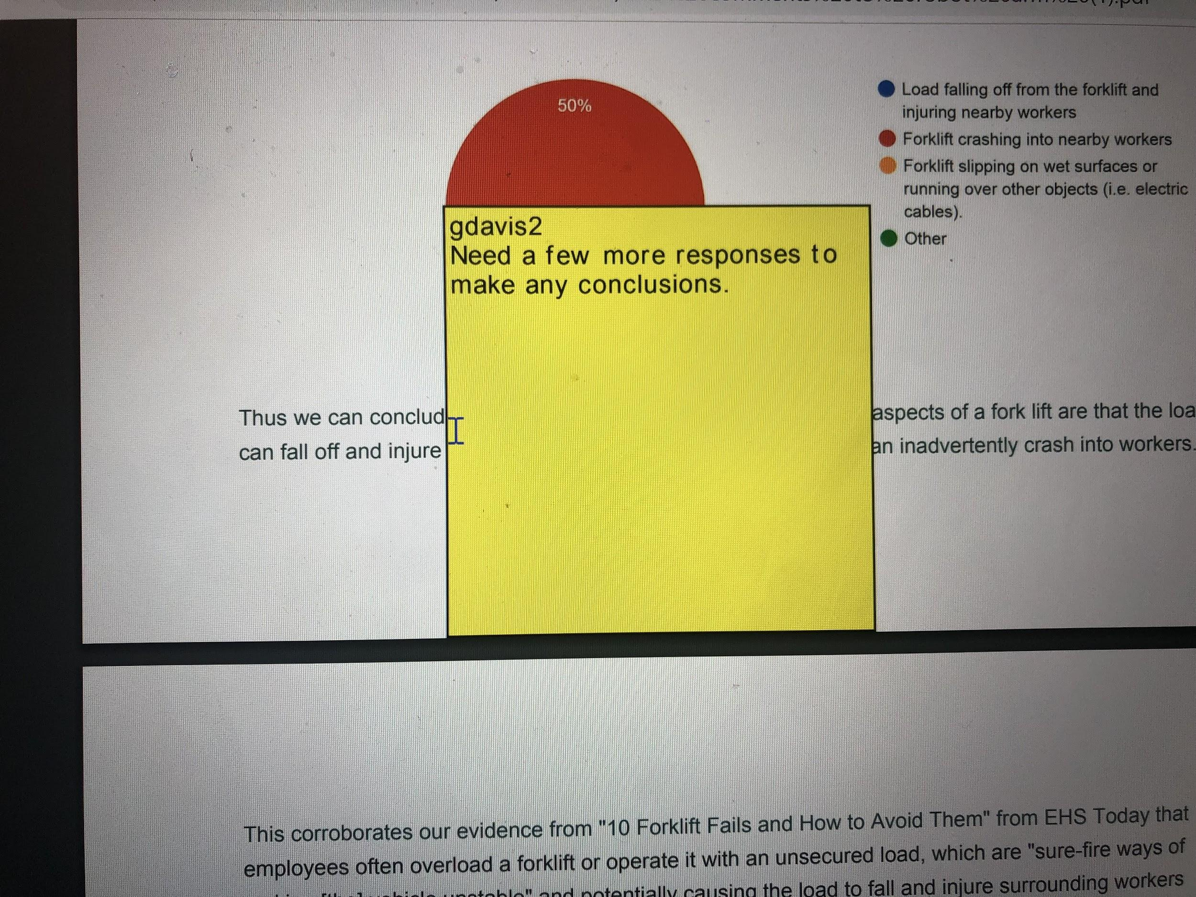

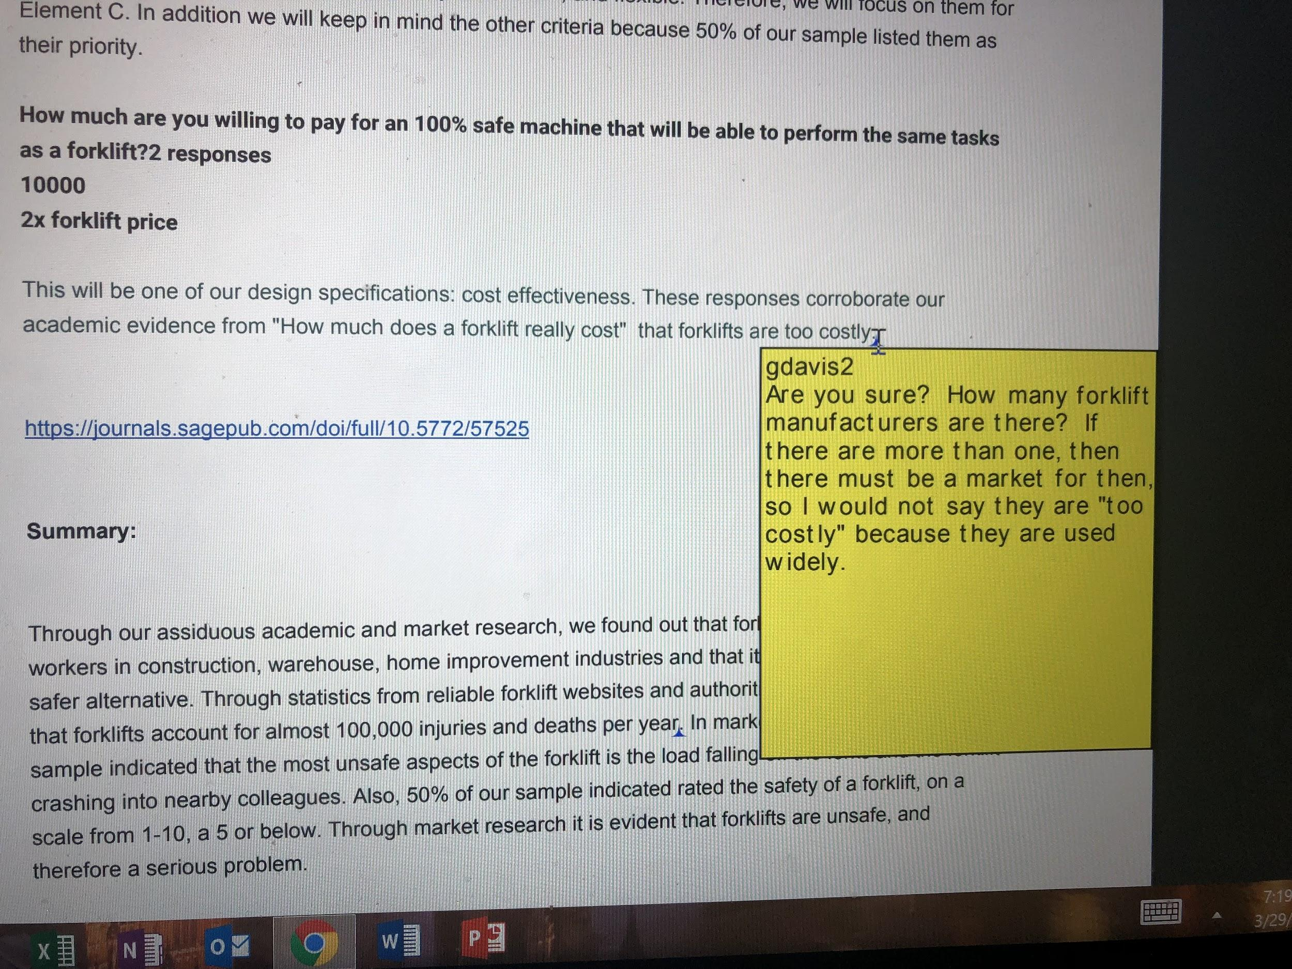

We said that forklifts are too costly, but that is wrong because a market exists for them. Safety and difficulty of operation, not cost, are the problems. We will revise our cost criteria so that it is like “Our new safer design should cost x times more than the cost of a standard forklift.”

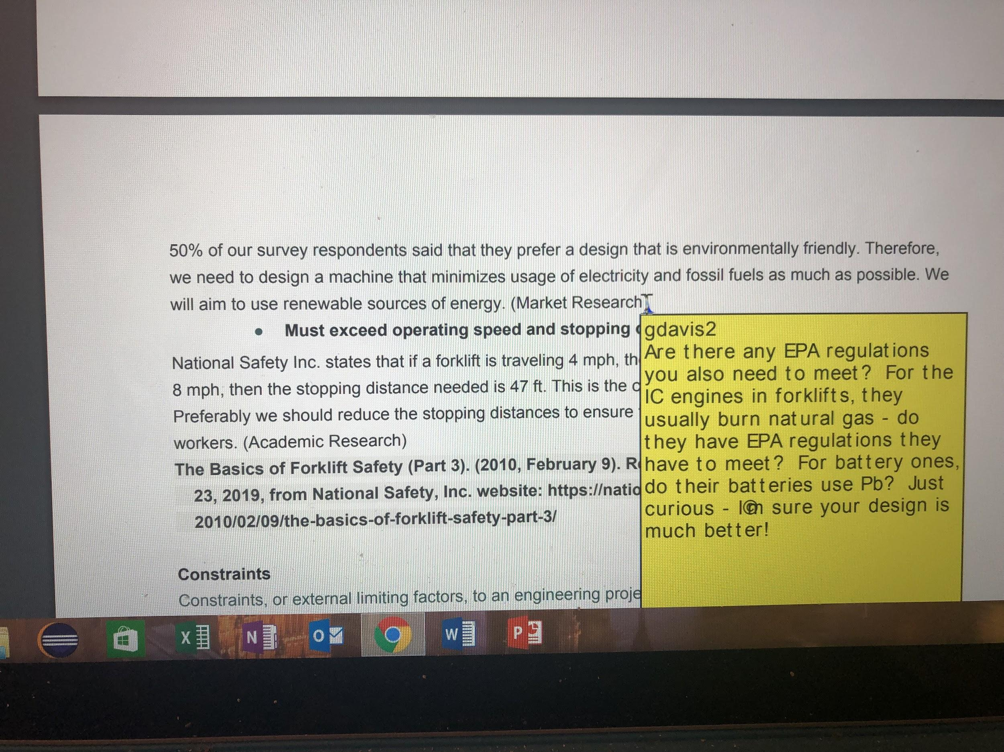

Our environmentally friendly criteria is lacking because it doesn’t say any specific regulations that we have to meet. We have to perform more research on certain fossil fuel regulations for forklifts.

**Expert 2: David Smith (Vice President, Mechanical Engineering Consultant, Patent, and Design Safety Expert Witness for Alpine Engineering and Design, Inc)**

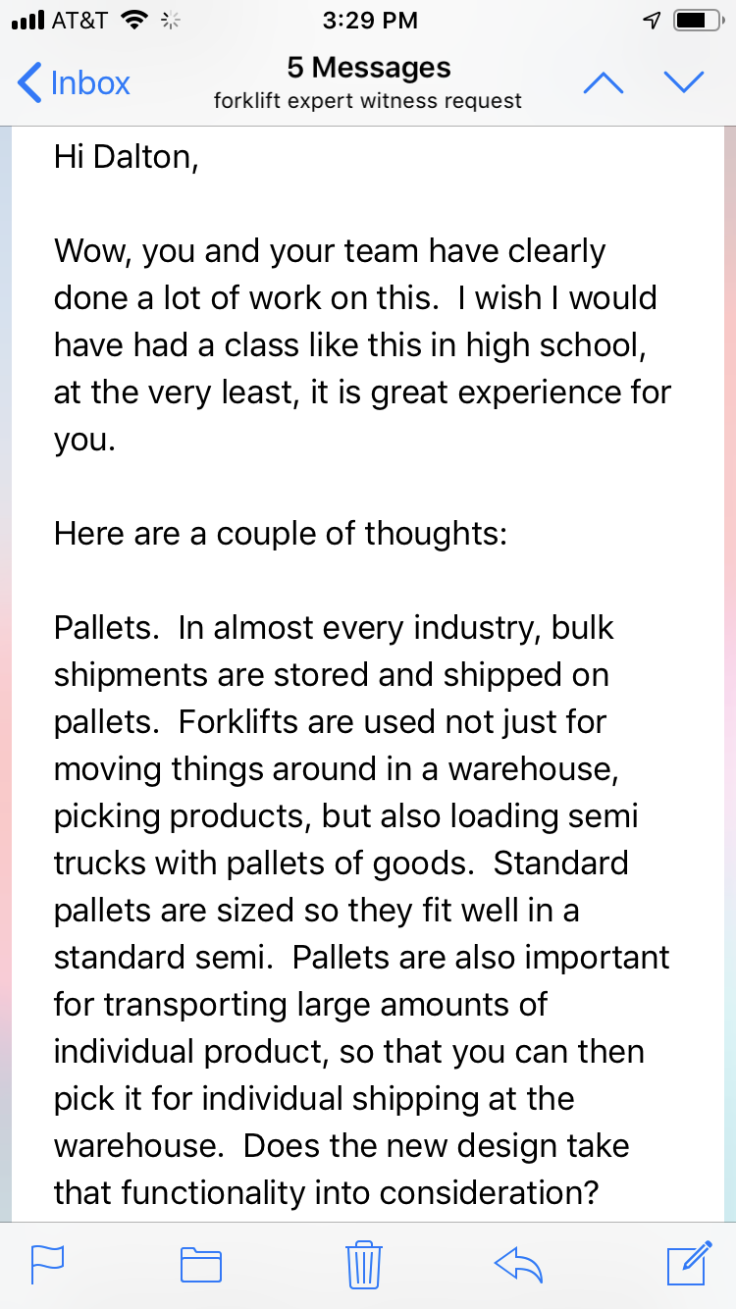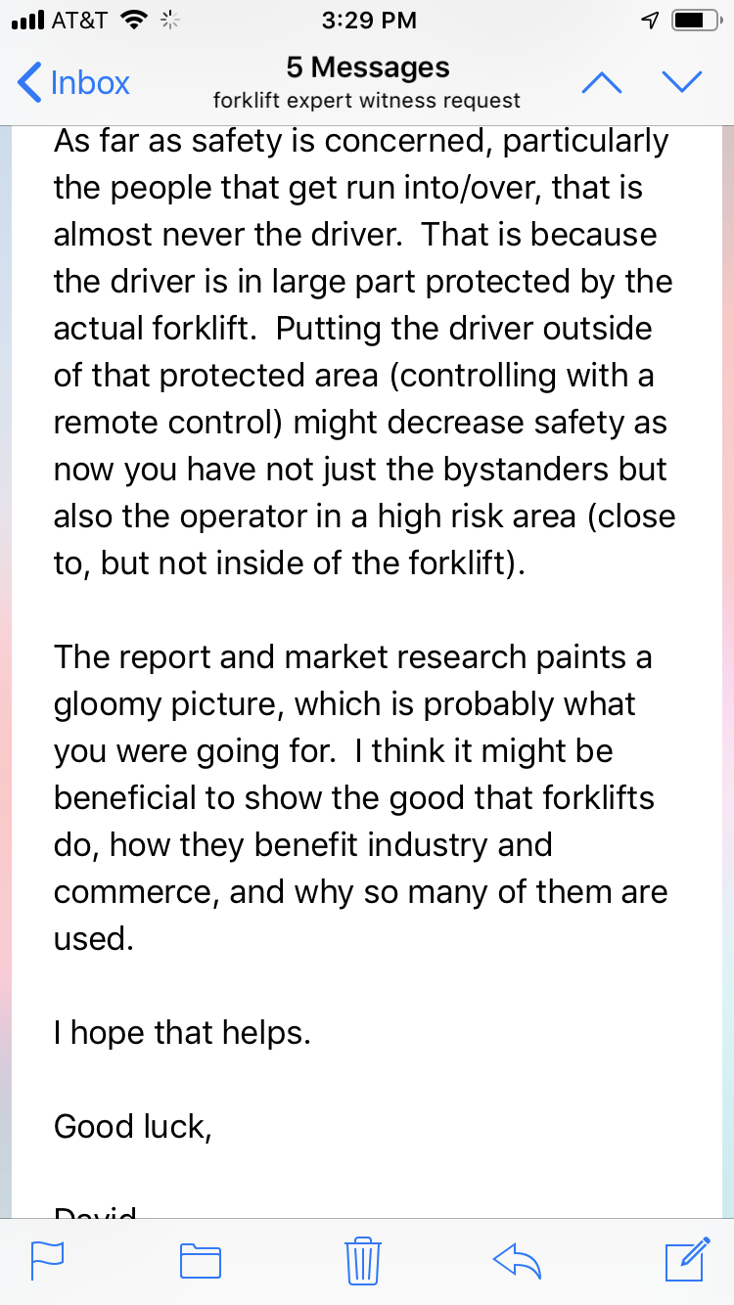

We asked David Smith, a forklift safety expert, to review our Innovation Portal elements A-F and give advice and feedback. Having someone who specializes in forklift safety do this was valuable because it helped us verify our research from a credible source, making it more sound. He also gave us suggestions, like consideration of pallets and an addition of how forklifts benefit industry, to make our portfolio more nuanced and advanced.

**Summary of Element J**

Thus, contacting multiple experts that specialize in a certain aspect of our project was worthwhile because they gave us credible and insightful feedback, suggestions, and corrections to make our the project more impressive. Corroboration and modification based on expert feedback is an important engineering skill.

**Element K: Individual Reflection**

**Alex Luu’s Element K**

This project was difficult for myself, not because the basic idea was confusing to understand, but because of the inability to gather the required resources to undertake such a grand project. Through the year we found ourselves having to remove many elements from the initial design, not only because of the shoestring budget, but also because of time constraints. This resulted in a prototype that was barebones and not even able to do half of the initially advertised objectives.

I started out with much hope that this could eventually lead to a marked improvement to workers’ safety in future, and that the arm would provide the first step to achieving that. However, this hope was wildly diminished when we came upon the logistical and budgetary issues that came from undertaking such a large project. Despite this initial setback, these limits allowed us to get creative, and gradually, we assembled a crude robotic arm from limited materials and time.

When we first set out on our project, our problem statement was more oriented towards general worker safety than the more specific forklift idea, and I personally had a vision where mechanized systems could prevent many injuries, from doctors and their patients to soldiers. I conducted market research based on the initial premise, while the rest of my group spent their time researching similar projects and background information. While the results were informative, my work was rendered obsolete when we were forced to refine the issue into a narrower purpose, and I instead started to research potential ideas to add to the basic arm design.

Despite this setback, we set upon designing the arm. After we brainstormed multiple initial designs, we decided that the best solution would incorporate all of our concepts. And that is what we did, enabling us to design a machine that would be more versatile than any of our individual ideas. We then took it upon ourselves to actually construct the arm.

We went our separate ways, primarily working on our own pieces and later on convening to assemble the arm. Dalton and I worked on the arm, while Felix worked on assembling the hand, and Alex W. worked on the programming and 3D printing. While we did so, we altered those final plans to make the arm more efficient and effective, as well as account for unforeseen issues with the arm. Even with these alterations, we managed to keep the arm in coherent working order.

Originally, the robotic arm would be situated on a mobile platform, able to move in any direction to pick up a needed load, and be controlled via various sensors on a worker’s arm, using motion capture to mimic that person’s movement. However, the project was downscaled once we realized how prohibitive the costs were and how diminished our budget was. Even then, we assumed that those parts were already made and could be easily adjusted to accommodate the arm.

The lack of materials and money forced us to get creative with the materials we had, which led me to construct an arm out of wood and supported by wires and a pneumatic system to move the various sections of the arm around, instead of the usual hydraulic system used by industrial arms. Even with our resourcefulness, we could not build the final design as initially perceived, but instead we had built the bare basics of the arm, assuming that the rest of the project, had we the money to acquire those parts, would be easily attachable.

Ultimately, the robotic arm idea was a solution without a problem, and the project suffered due to the various constraints surrounding the problem, in addition to the monetary and time issues. Crucially, the insufficient number of motors meant we could not assemble many of the moving parts beyond the arm, including the platform it was situated on, and the costs of a motion capture system was far beyond our budget. In the end, while we got a robotic arm working, the final product achieved much less than my own hopes & expectations.

Element K: Felix Xu

Our project was a big idea and had encountered some difficulties throughout the year. The research process was a long process especially for our project because our idea was comprehensive and had such a specific problem to solve. We went with the problem of forklift safety, but we later realized that our project would be better suited to cherry picker trucks. Our design process was varying with different types of interpretations of our robot arm. I intended to place the arm on a moving platform. While the other group members had similar ideas, many of them also contained other unique ideas of how to utilize the arm. No single idea was better than another, so we had to come up with a new idea that combined the best aspects of all the ideas presented. We did realize that our idea would be huge if we went with the entire aspect of the idea, so we focused instead on just the arm portion of the design. Once it can down to the idea we wanted, we started to gather materials for our arm. I started to model the “wrist” portion of our arm and tried to come up with a way to mount our fingers on a base while also giving it room to rotate as like a real wrist. I conferred with my partners about the designs, and they believed it was great. Overall, the build of our project required multiple parts for each member working on different aspects of our robotic arm. I was responsible for the finger mechanism. I had to contact an expert on mechanical engineering for advice on how to most effectively move each finger without any additional use of expensive materials.

Once I had finalized the design, we started our assembly stage. This stage took longer than expected because the 3D printer ran into issues while printing our part. These issues along with other groups using the printer delayed our assembly stage. After all the parts need had been created, I started to assemble the parts of the finger, after lots of filing to remove any excess plastic. We had most of the parts ready to be assembled, but we wanted to confer with another expert about our overall design.

We met with Mr. Davis and asked some advice about any potential issue or other additions that could serve as useful additions to our project. He gave us lots of useful advice which we did take into consideration. We needed to rethink how the “elbow” portion of our arm was going to function. Testing was also a big roadblock because our motors, which move the “wrist” and “finger” portion of our arm, had some coding issues that needed resolving if we were to proceed. After we recently resolved the issues, we can begin our assembly process. I believe that our project as a whole is a great idea. It's unique in its way, and it has opened my eyes to the process of how creating a product. Looking back I definitely would have done the process differently. We should have invited our expert over before we decided on which design to choose — having this information would simply the build process and eliminate any issues before they arrive. Although I enjoy my project and its idea, I wish we had chosen an idea that was simpler and didn’t require as much time as our current idea does.

Alex Westerman: Element K Reflection

Personally, I have very mixed feelings about this project. While I enjoyed working with my teammates and got to build an amazing project with them, I feel that I have made too many sacrifices for this project.

When we first came together as a group, we felt that we had a very solid idea on how we were to approach the prototype. We recognized our original design would not be completed in time for the jury date, so we decided to simplify it, removing ambitious features such as motion-activated controls and electromagnetic gripping. We recognized our base constraints for this project (time, resources, size, etc.), but there were additional unnecessary constraints that did cause issues with our project. One was the lack of a coherent or sufficient budget. While we did understand we can’t spend a lot of money, I had to invest $130 of my own money before the project budget was even announced so we can start prototyping. PLTW supposedly requires each student in EDD to have $100 budget for their project, making the total budget $400 for the group. The school’s foundation only gave us $100 per group, or $25 per person. We went over budget and still required more resources, we only purchased the motors and the Arduino unit. This budget constraint really made the project much more difficult because we had to purchase electronics that had less quality and impacted our project functionality. I’ve had to spend more than 10 hours in total trying to salvage broken parts, which is an absurd amount of time for any type of project. Also, the low quality of the parts contributed to a burnt motor driver and my laptop motherboard fried after a short circuit through the USB ports. To this day Lenovo support is still holding it hostage under the reasoning of cosmetic damage that I still must negotiate with them about. I had to borrow my father’s laptop because the school would not install the right software needed for development. This was a major setback that could have been avoided if our budget allowed for us to use better quality parts.

The next issue I had was with the timeframe we were given. Throughout this project, our entire group was very vocal that the project needs a long time for the prototyping process, especially given the constraints we were working with. We worked as efficiently as we could while trying to maintain quality, but it overall led to us pushing out the rest of the project on overtime within a month before the jury date. I have spent countless nights staying up debugging code. I have commits in version control at 1am in the morning where I would complain about how I can’t figure out errors. I have broken down in front of my grandparents at a public restraint when they did not understand the unusual circumstances that our group was in. I got security called on me after arguing with a substitute teacher about if a glue gun is a power tool. And for that matter, my parents are very concerned about my mental well-being, with me missing the bus on a consistent every-other-day basis, getting less than 4 hours of sleep on some days. I’ve had a craving for non-caffeinated sodas because it helps my wired ADHD mind, pouring into funds that are depleting faster with no way to replenish it. I feel that we tried to work the hardest possible, but there was no recognition or observance of personal health throughout this project that has put me through one of the most stressful points in my life. I don’t think I would have seen the end of the project if it wasn’t for my supporting parents, friends, and group mates that understood the strain I was going through and tried to help alleviate the load.

The last issue is about documentation. While I understand that all projects require documentation of how it was designed and how it works as proof of intellectual property, the depth asked for said documentation is ridiculous. The programming I had to do involves pointers, an extremely difficult concept in C programming language that would require at least a few years of experience to understand. I recognize that I may not be presenting this to actual electrical engineers, but on the other hand, asking me to comment and explain every line of code would be an injustice to the formatting and a pain in the rear. I had to rewrite the firmware starting at the beginning of May because the original open-source firmware I modified had too much code that would have taken me months to fully document to the expected standards. Programming documentation is also the worst way to understand a project. If someone tried to learn Java using the standardized Javadoc documentation, they would be easily discouraged with the complicated description of commonly used classes or objects such as the String class. I still need to write the electrical build procedure (at the time of this writing) which has been delayed because of the programming and the number of repairs I had to do. I wish I did have someone that could help me, but unfortunately, I am the only programmer with this amount of experience taking this course in my school. And the fact that the jury may ask questions about code that only I myself would know by the back of my hand would be an injustice to the other aspects of the project (especially paperwork and the pneumatics) that they have worked just as hard on.

While most of this reflection was criticism of the course and my negative experiences, I do not want to gloss over the few positives with this project. I am happy to have had this opportunity to put this much passion into a project purely for my education, and I could not be happier to have amazing groupmates that had a similar vision to myself. I am sure to take all of this experience and use it to pursue higher education and continue to have fun with making things.

Signed,

Alex Westerman

5/15/19

**Element L: Presentation of Designer’s Recommendation**s

* Problem Statement
* Product Recommendations
  + Recommendations
  + Further Testing
  + Manufacturing Process
  + Materials
* Summary

**Recommendations:** Run more trials of tests to be extra sure, leave extra time for building because you never know how long is it going to take. Always be in contact with experts because they could provide valuable information you wouldn’t be able to get without them.

An improvement is that we should include more research to justify our problem.

**Further Testing:** Due to the budgetary constraints of the arm, it is currently unknown how the arm will function on an mobile platform, in tandem with a second arm, or if motion capture would be able to make the arm accurately mimic a human arm. If there was more time and money, testing those features would be highly recommended.

**Manufacturing Process/Materials:** While the prototype was constructed from spare wood and used a primitive pneumatic setup along with wires, future arms would be constructed out of metal, laminated with plastic, and using a hybrid setup of wires and hydraulics. The metal would replace the wood, and the hydraulics would replace the pneumatics as well as introduce additional pneumatics to support the arm. Additionally, attaching the arm to a mobile platform is recommended in order to move the arm in additional ways and extra directions, and alloting two arms to a platform would make the arms more effective in grabbing large items.